Solution and Answer Guide
Camm/Cochran/Fry/Ohlmann/Anderson/Sweeney/Williams, Essentials of Modern Business Statistics w/MS Excel 9th Edition, 9780357984505; Chapter 14: Simple Linear Regression
Table of Contents
Exercises 1
Supplementary Exercises 72
Case Problem 1: Measuring Stock Market Risk 97
Case Problem 2: U.S. Department of Transportation 99
Case Problem 3: Selecting a Point-and-Shoot Digital Camera 102
Case Problem 4: Finding the Best Car Value 107
Case Problem 5: Buckeye Creek Amusement Park 111

Exercises
Methods
1. Given are five observations for two variables, x and y. LO 1, 2
x_{i} | 1 | 2 | 3 | 4 | 5
y_{i} | 3 | 7 | 5 | 11 | 14
a. Develop a scatter diagram for these data.
b. What does the scatter diagram developed in part (a) indicate about the relationship between the two variables?
c. Try to approximate the relationship between x and y by drawing a straight line through the data.
d. Develop the estimated regression equation by computing the values of b₀ and b₁ using equations (14.6) and (14.7).
e. Use the estimated regression equation to predict the value of y when x = 4.
Solutions:
a.

b. There appears to be a positive linear relationship between x and y.
c. Many different straight lines can be drawn to provide a linear approximation of the relationship between x and y; in part (d) we will determine the equation of a straight line that “best” represents the relationship according to the least squares criterion.
d.
e.
2. Given are five observations for two variables, x and y. LO 1, 2
x_{i} | 3 | 12 | 6 | 20 | 14
y_{i} | 55 | 40 | 55 | 10 | 15
a. Develop a scatter diagram for these data.
b. What does the scatter diagram developed in part (a) indicate about the relationship between the two variables?
c. Try to approximate the relationship between x and y by drawing a straight line through the data.
d. Develop the estimated regression equation by computing the values of b₀ and b₁ using equations (14.6) and (14.7).
e. Use the estimated regression equation to predict the value of y when x = 10.
Solutions:
a.

b. There appears to be a negative linear relationship between x and y.
c. Many different straight lines can be drawn to provide a linear approximation of the relationship between x and y; in part (d), we will determine the equation of a straight line that “best” represents the relationship according to the least squares criterion.
d.
e.
3. Given are five observations collected in a regression study on two variables. LO 1, 2
x_{i} | 2 | 6 | 9 | 13 | 20
y_{i} | 7 | 18 | 9 | 26 | 23
a. Develop a scatter diagram for these data.
b. Develop the estimated regression equation for these data.
c. Use the estimated regression equation to predict the value of y when x = 6.
Solutions:

b.
c.
Applications
4. Retail and Trade: Female Managers. The following data give the percentage of women working in five companies in the retail and trade industry. The percentage of management jobs held by women in each company is also shown. LO 1, 2
% Working | 67 | 45 | 73 | 54 | 61
% Management | 49 | 21 | 65 | 47 | 33
a. Develop a scatter diagram for these data with the percentage of women working in the company as the independent variable.
b. What does the scatter diagram developed in part (a) indicate about the relationship between the two variables?
c. Try to approximate the relationship between the percentage of women working in the company and the percentage of management jobs held by women in that company.
d. Develop the estimated regression equation by computing the values of b₀ and b₁.
e. Predict the percentage of management jobs held by women in a company that has 60% women employees.
Solutions:
a.

b. There appears to be a positive linear relationship between the percentage of women working in the five companies (x) and the percentage of management jobs held by women in that company (y).
c. Many different straight lines can be drawn to provide a linear approximation of the relationship between x and y; in part (d), we will determine the equation of a straight line that “best” represents the relationship according to the least squares criterion.
d.
e.
5. Production Line Speed and Quality Control. Brawdy Plastics, Inc., produces plastic seat belt retainers for General Motors at their plant in Buffalo, New York. After final assembly and painting, the parts are placed on a conveyor belt that moves the parts past a final inspection station. How fast the parts move past the final inspection station depends upon the line speed of the conveyor belt (feet per minute). Although faster line speeds are desirable, management is concerned that increasing the line speed too much may not provide enough time for inspectors to identify which parts are actually defective. To test this theory, Brawdy Plastics conducted an experiment in which the same batch of parts, with a known number of defective parts, was inspected using a variety of line speeds. The following data were collected. LO 1, 2
Line  Speed | Number of Defective Parts Found
20 | 23
20 | 21
30 | 19
30 | 16
40 | 15
40 | 17
50 | 14
50 | 11
a. Develop a scatter diagram with the line speed as the independent variable.
b. What does the scatter diagram developed in part (a) indicate about the relationship between the two variables?
c. Use the least squares method to develop the estimated regression equation.
d. Predict the number of defective parts found for a line speed of 25 feet per minute.
Solutions:
a.

b. There appears to be a negative relationship between line speed (feet per minute) and the number of defective parts.
c. Let x = line speed (feet per minute) and y = number of defective parts.
d.
6. Passing and Winning in the NFL. The National Football League (NFL) records a variety of performance data for individuals and teams. To investigate the importance of passing on the percentage of games won by a team, the following data show the average number of passing yards per attempt (Yds/Att) and the percentage of games won in a season (WinPct) for a random sample of 10 NFL teams. LO 1, 2, 3
Team | Yds/Att | WinPct
Arizona Cardinals | 6.5 | 50
Atlanta Falcons | 7.1 | 63
Carolina Panthers | 7.4 | 38
Chicago Bears | 6.4 | 50
Dallas Cowboys | 7.4 | 50
New England Patriots | 8.3 | 81
Philadelphia Eagles | 7.4 | 50
Seattle Seahawks | 6.1 | 44
St. Louis Rams | 5.2 | 13
Tampa Bay Buccaneers | 6.2 | 25
a. Develop a scatter diagram with the number of passing yards per attempt on the horizontal axis and the percentage of games won on the vertical axis.
b. What does the scatter diagram developed in part (a) indicate about the relationship between the two variables?
c. Develop the estimated regression equation that could be used to predict the percentage of games won given the average number of passing yards per attempt.
d. Provide an interpretation for the slope of the estimated regression equation.
e. For the 2011 season, the average number of passing yards per attempt for the Kansas City Chiefs was 6.2. Use the estimated regression equation developed in part (c) to predict the percentage of games won by the Kansas City Chiefs. (Note: For the 2011 season the Kansas City Chiefs’ record was seven wins and nine losses.) Compare your prediction to the actual percentage of games won by the Kansas City Chiefs.
Solutions:
a.

b. The scatter diagram indicates a positive linear relationship between x = average number of passing yards per attempt and y = the percentage of games won by the team.
c.
d. The slope of the estimated regression line is approximately 17.2. So, for every increase of one yard in the average number of passes per attempt, the percentage of games won by the team increases by 17.2%.
e. With an average number of passing yards per attempt of 6.2, the predicted percentage of games won is = –70.391 + 17.175(6.2) = 36%. With a record of seven wins and nine losses, the percentage of games that the Kansas City Chiefs won is 43.8 or approximately 44%. Considering the small data size, the prediction made using the estimated regression equation is not too bad.
7. Sales Experience and Performance. A sales manager collected the following data on annual sales for new customer accounts and the number of years of experience for a sample of 10 salespersons. LO 1, 2
Salesperson | Years of  Experience | Annual Sales  ($1,000s)
1 | 1 | 80
2 | 3 | 97
3 | 4 | 92
4 | 4 | 102
5 | 6 | 103
6 | 8 | 111
7 | 10 | 119
8 | 10 | 123
9 | 11 | 117
10 | 13 | 136
a. Develop a scatter diagram for these data with years of experience as the independent variable.
b. Develop an estimated regression equation that can be used to predict annual sales given the years of experience.
c. Use the estimated regression equation to predict annual sales for a salesperson with nine years of experience.
Solutions:
a.

b. Let x = years of experience and y = annual sales ($1,000s)
c. or $116,000
8. Broker Satisfaction. The American Association of Individual Investors (AAII) On-Line Discount Broker Survey polls members on their experiences with discount brokers. As part of the survey, members were asked to rate the quality of the speed of execution with their broker as well as provide an overall satisfaction rating for electronic trades. Possible responses (scores) were no opinion (0), unsatisfied (1), somewhat satisfied (2), satisfied (3), and very satisfied (4). For each broker summary scores were computed by calculating a weighted average of the scores provided by each respondent. A portion of the survey results follow (AAII website). LO 1, 2, 3
Brokerage | Speed | Satisfaction
Scottrade, Inc. | 3.4 | 3.5
Charles Schwab | 3.3 | 3.4
Fidelity Brokerage Services | 3.4 | 3.9
TD Ameritrade | 3.6 | 3.7
E*Trade Financial | 3.2 | 2.9
Vanguard Brokerage Services | 3.8 | 2.8
USAA Brokerage Services | 3.8 | 3.6
Thinkorswim | 2.6 | 2.6
Wells Fargo Investments | 2.7 | 2.3
Interactive Brokers | 4.0 | 4.0
Zecco.com | 2.5 | 2.5
a. Develop a scatter diagram for these data with the speed of execution as the independent variable.
b. What does the scatter diagram developed in part (a) indicate about the relationship between the two variables?
c. Develop the least squares estimated regression equation.
d. Provide an interpretation for the slope of the estimated regression equation.
e. Suppose Zecco.com developed new software to increase their speed of execution rating. If the new software is able to increase their speed of execution rating from the current value of 2.5 to the average speed of execution rating for the other 10 brokerage firms that were surveyed, what value would you predict for the overall satisfaction rating?
Solutions:
a.

b. The scatter diagram indicates a positive linear relationship between x = speed of execution rating and y = overall satisfaction rating for electronic trades.
c.
- The slope of the estimated regression line is approximately 0.9077. So, a one unit increase in the speed of execution rating will increase the overall satisfaction rating by approximately 0.9 points.
- The average speed of execution rating for the other brokerage firms is 3.38. Using this
as the new value of x for Zecco.com, we can use the estimated regression equation developed in part (c) to estimate the overall satisfaction rating corresponding to x = 3.38.
Thus, an estimate of the overall satisfaction rating when x = 3.38 is approximately 3.3.
9. Estimating Landscaping Expenditures. David’s Landscaping has collected data on home values (in thousands of $) and expenditures (in thousands of $) on landscaping with the hope of developing a predictive model to help marketing to potential new clients. Data for 14 households may be found in the file landscape. LO 1, 2, 3
a. Develop a scatter diagram with home value as the independent variable.
b. What does the scatter plot developed in part (a) indicate about the relationship between the two variables?
c. Use the least squares method to develop the estimated regression equation.
d. For every additional $1,000 in home value, estimate how much additional will be spent on landscaping.
e. Use the equation estimated in part (c) to predict the landscaping expenditures for a home valued at $575,000.
Solutions:
a.

b. The scatter diagram indicates a positive linear relationship between x = Home Value ($ thousands) and y = landscaping expenditures ($ thousands).
c.
y = 0.0214x + 6.3091
d. For every additional $1,000 in home value, $21.40 is spent on landscaping.
e. or $18,614
10. Age and the Price of Wine. For a particular red wine, the following data show the auction price for a 750-milliliter bottle and the age of the wine as of June 2016 (WineX website). LO 1, 3
Age (years) | Price ($)
36 | 256
20 | 142
29 | 212
33 | 255
41 | 331
27 | 173
30 | 209
45 | 297
34 | 237
22 | 182
a. Develop a scatter diagram for these data with age as the independent variable.
b. What does the scatter diagram developed in part (a) indicate about the relationship between age and price?
c. Develop the least squares estimated regression equation.
d. Provide an interpretation for the slope of the estimated equation.
Solutions:
a.

b. The scatter diagram indicates a positive linear relationship between x = age of wine and y = price of a 750-ml bottle of wine. In other words, the price of the wine increases with age.
c.
d. The slope of the estimated regression line is approximately 6.95. So, for every additional year of age, the price of the wine increases by $6.95.
11. Laptop Ratings. To help consumers in purchasing a laptop computer, Consumer Reports calculates an overall test score for each computer tested based upon rating factors such as ergonomics, portability, performance, display, and battery life. Higher overall scores indicate better test results. The following data show the average retail price and the overall score for ten 13-inch models (Consumer Reports website). LO 1, 2, 3
Brand and Model | Price  ($) | Overall  Score
Samsung Ultrabook NP900X3C-A01US | 1,250 | 83
Apple MacBook Air MC965LL/A | 1,300 | 83
Apple MacBook Air MD231LL/A | 1,200 | 82
HP ENVY 13-2050nr Spectre XT | 950 | 79
Sony VAIO SVS13112FXB | 800 | 77
Acer Aspire S5-391-9880 Ultrabook | 1,200 | 74
Apple MacBook Pro MD101LL/A | 1,200 | 74
Apple MacBook Pro MD313LL/A | 1,000 | 73
Dell Inspiron I13Z-6591SLV | 700 | 67
Samsung NP535U3C-A01US | 600 | 63
a. Develop a scatter diagram with price as the independent variable.
b. What does the scatter diagram developed in part (a) indicate about the relationship between the two variables?
c. Use the least squares method to develop the estimated regression equation.
d. Provide an interpretation of the slope of the estimated regression equation.
e. Another laptop that Consumer Reports tested is the Acer Aspire S3-951-6646 Ultrabook; the price for this laptop was $700. Predict the overall score for this laptop using the estimated regression equation developed in part (c).
Solutions:
a.

b. The scatter diagram indicates a positive linear relationship between x = price ($) and
y = overall score.
c.
d. The slope of 0.0212 means that spending an additional $100 in price will increase the overall score by approximately two points.
e. A prediction of the overall score is
12. Stock Beta. In June 2016, Yahoo Finance reported the beta value for Coca-Cola was 0.82 (Yahoo Finance website). Betas for individual stocks are determined by simple linear regression. The dependent variable is the total return for the stock, and the independent variable is the total return for the stock market, such as the return of the S&P 500. The slope of this regression equation is referred to as the stock’s beta. Many financial analysts prefer to measure the risk of a stock by computing the stock’s beta value.
The data contained in the file CocaCola show the monthly percentage returns for the S&P 500 and the Coca-Cola Company for 12 months. LO 1, 3
Month | S&P 500  % Return | Coca-Cola  % Return
August | –3 | 3
September | 8 | 6
October | 0 | 1
November | –2 | 1
December | –5 | 0
January | 0 | 0
February | 7 | 8
March | 0 | –3
April | 2 | 0
May | –5 | –1
a. Develop a scatter diagram with the S&P % Return as the independent variable.
b. What does the scatter diagram developed in part (a) indicate about the relationship between the returns of the S&P 500 and those of the Coca-Cola Company?
c. Develop the least squares estimated regression equation.
d. Provide an interpretation for the slope of the estimated equation (i.e., the beta).
e. Is your beta estimate close to 0.82? If not, why might your estimate be different?
Solutions:
a.

b. The scatter diagram indicates a somewhat positive linear relationship between
x = percentage return of the S&P 500 and y = percentage return for Coca-Cola.
c.
d. A 1% increase in the percentage return of the S&P 500 will result in a 0.529 increase in the percentage return for Coca-Cola.
- The beta of 0.529 for Coca-Cola differs somewhat from the beta of 0.82 reported by Yahoo Finance. This is likely due to differences in the period over which the data were collected and the amount of data used to calculate the beta. Note: Yahoo uses the last five years of monthly returns to calculate beta.
13. Auditing Itemized Tax Deductions. To the Internal Revenue Service (IRS), the reasonableness of total itemized deductions depends on the taxpayer’s adjusted gross income. Large deductions, which include charity and medical deductions, are more reasonable for taxpayers with large adjusted gross incomes. If a taxpayer claims larger than average itemized deductions for a given level of income, the chances of an IRS audit are increased. Data (in thousands of dollars) on adjusted gross income and the average or reasonable amount of itemized deductions follow. LO 1, 2
Adjusted Gross Income ($1,000s) | Reasonable Amount of  Itemized Deductions ($1,000s)
22 | 9.6
27 | 9.6
32 | 10.1
48 | 11.1
65 | 13.5
85 | 17.7
120 | 25.5
a. Develop a scatter diagram for these data with adjusted gross income as the independent variable.
b. Use the least squares method to develop the estimated regression equation.
c. Predict the reasonable level of total itemized deductions for a taxpayer with an adjusted gross income of $52,500. If this taxpayer claimed itemized deductions of $20,400, would the IRS agent’s request for an audit appear justified? Explain.
Solutions:
a. 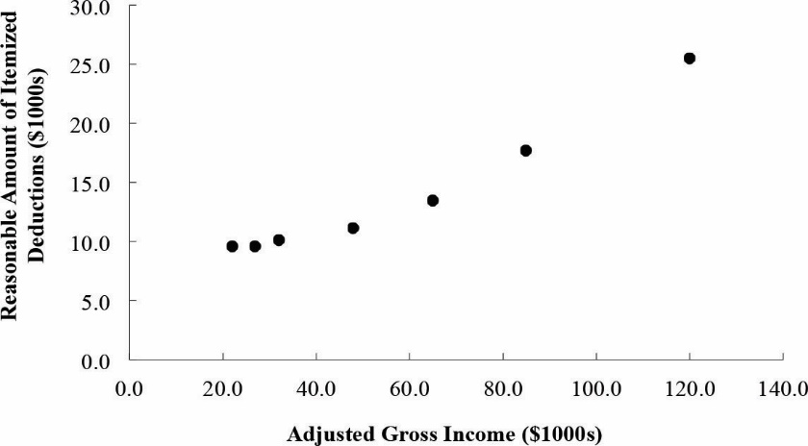
b. Let x = adjusted gross income and y = reasonable amount of itemized deductions.
c. or approximately $13,080. The agent's request for an audit appears to be justified.
14. Distance and Absenteeism. A large city hospital conducted a study to investigate the relationship between the number of unauthorized days that employees are absent per year and the distance (miles) between home and work for the employees. A sample of 10 employees was selected and the following data were collected. LO 1, 2
Distance to Work  (miles) | Number of Days  Absent
1 | 8
3 | 5
4 | 8
6 | 7
8 | 6
10 | 3
12 | 5
14 | 2
14 | 4
18 | 2
a. Develop a scatter diagram for these data. Does a linear relationship appear reasonable? Explain.
b. Develop the least squares estimated regression equation that relates the distance to work to the number of days absent.
c. Predict the number of days absent for an employee that lives five miles from the hospital.
Solutions:
a.

The scatter diagram indicates a negative linear relationship between x = distance to work and y = number of days absent.
b.
c. A prediction of the number of days absent is , or approximately six days.
Methods
15. The data from exercise one follow. LO 4, 5
x_{i} | 1 | 2 | 3 | 4 | 5
y_{i} | 3 | 7 | 5 | 11 | 14
The estimated regression equation for these data is = 0.20 + 2.60x.
a. Compute SSE, SST, and SSR using equations (14.8), (14.9), and (14.10).
b. Compute the coefficient of determination r². Comment on the goodness of fit.
c. Compute the sample correlation coefficient.
Solutions:
a. The estimated regression equation and the mean for the dependent variable are:
The sum of squares due to error and the total sum of squares are
Thus, SSR = SST – SSE = 80 – 12.4 = 67.6
b. r² = SSR/SST = 67.6/80 = 0.845
The least squares line provided a very good fit; 84.5% of the variability in y has been explained by the least squares line.
c.
16. The data from exercise two follow. LO 4, 5
x_{i} | 3 | 12 | 6 | 20 | 14
y_{i} | 55 | 40 | 55 | 10 | 15
The estimated regression equation for these data is = 68 – 3x.
a. Compute SSE, SST, and SSR.
b. Compute the coefficient of determination r². Comment on the goodness of fit.
c. Compute the sample correlation coefficient.
Solutions:
a. The estimated regression equation and the mean for the dependent variable are:
The sum of squares due to error and the total sum of squares are
Thus, SSR = SST – SSE = 1,850 – 230 = 1,620
b. r² = SSR/SST = 1,620/1,850 = 0.876
The least squares line provided an excellent fit; 87.6% of the variability in y has been explained by the estimated regression equation.
c.
Note: The sign for r is negative because the slope of the estimated regression equation is negative.
(b₁ = –3)
17. The data from exercise three follow. LO 4, 5
x_{i} | 2 | 6 | 9 | 13 | 20
y_{i} | 7 | 18 | 9 | 26 | 23
The estimated regression equation for these data is = 7.6 + 0.9x. What percentage of the total sum of squares can be accounted for by the estimated regression equation? What is the value of the sample correlation coefficient?
Solutions:
The estimated regression equation and the mean for the dependent variable are:
The sum of squares due to error and the total sum of squares are
Thus, SSR = SST – SSE = 281.2 – 127.3 = 153.9
r² = SSR/SST = 153.9/281.2 = 0.547
We see that 54.7% of the variability in y has been explained by the least squares line.
Applications
18. Price and Quality of Headphones. The following data show the brand, price ($), and the overall score for six stereo headphones that were tested by Consumer Reports (Consumer Reports website). The overall score is based on sound quality and effectiveness of ambient noise reduction. Scores range from zero (lowest) to 100 (highest). The estimated regression equation for these data is = 23.194 + 0.318x, where x = price ($) and y = overall score.
LO 4, 5
Brand | Price ($) | Score
Bose | 180 | 76
Skullcandy | 150 | 71
Koss | 95 | 61
Phillips/O’Neill | 70 | 56
Denon | 70 | 40
JVC | 35 | 26
a. Compute SST, SSR, and SSE.
b. Compute the coefficient of determination r². Comment on the goodness of fit.
c. What is the value of the sample correlation coefficient?
Solutions:
a.
SSR = SST – SSR = 1,800 – 287.624 = 1,512.376
b.
The least squares line provided a very good fit; 84% of the variability in y has been explained by the least squares line.
c.
19. Sales Experience and Sales Performance. In exercise seven, a sales manager collected the following data on x = annual sales and y = years of experience. The estimated regression equation for these data is = 80 + 4x. LO 4, 5
Salesperson | Years of  Experience | Annual  Sales ($1,000s)
1 | 1 | 80
2 | 3 | 97
3 | 4 | 92
4 | 4 | 102
5 | 6 | 103
6 | 8 | 111
7 | 10 | 119
8 | 10 | 123
9 | 11 | 117
10 | 13 | 136
a. Compute SST, SSR, and SSE.
b. Compute the coefficient of determination r². Comment on the goodness of fit.
c. What is the value of the sample correlation coefficient?
Solutions:
a. The estimated regression equation and the mean for the dependent variable are:
= 80 + 4x = 108
The sum of squares due to error and the total sum of squares are
Thus, SSR = SST – SSE = 2,442 – 170 = 2,272
b. r² = SSR/SST = 2,272/2,442 = 0.93
We see that 93% of the variability in y has been explained by the least squares line.
c.
20. Price and Weight of Bicycles. Bicycling, the world’s leading cycling magazine, reviews hundreds of bicycles throughout the year. Their “Road-Race” category contains reviews of bikes used by riders primarily interested in racing. One of the most important factors in selecting a bike for racing is the weight of the bike. The following data show the weight (pounds) and price ($) for 10 racing bikes reviewed by the magazine (Bicycling website). LO 1, 2, 4
Brand | Weight | Price ($)
FELT F5 | 17.8 | 2,100
PINARELLO Paris | 16.1 | 6,250
ORBEA Orca GDR | 14.9 | 8,370
EDDY MERCKX EMX-7 | 15.9 | 6,200
BH RC1 Ultegra | 17.2 | 4,000
BH Ultralight 386 | 13.1 | 8,600
CERVELO S5 Team | 16.2 | 6,000
GIANT TCR Advanced 2 | 17.1 | 2,580
WILIER TRIESTINA Gran Turismo | 17.6 | 3,400
SPECIALIZED S-Works Amira SL4 | 14.1 | 8,000
a. Use the data to develop an estimated regression equation that could be used to estimate the price for a bike given the weight.
b. Compute r². Did the estimated regression equation provide a good fit?
c. Predict the price for a bike that weighs 15 pounds.
Solutions:
a.
b. SST = 52,120,800 SSE = 7,102,922.54
SSR = SST – SSR = 52,120,800 – 7,102,922.54 = 45,017,877.46
= SSR/SST = 45,017,877.46/52,120,800 = 0.864
The estimated regression equation provided a very good fit.
c.
Thus, an estimate of the price for a bike that weighs 15 pounds is $6,989.
21. Cost Estimation. An important application of regression analysis in accounting is in the estimation of cost. By collecting data on volume and cost and using the least squares method to develop an estimated regression equation relating volume and cost, an accountant can estimate the cost associated with a particular manufacturing volume. Consider the following sample of production volumes and total cost data for a manufacturing operation. LO 1, 2, 3, 4
Production Volume (units) | Total Cost ($)
400 | 4,000
450 | 5,000
550 | 5,400
600 | 5,900
700 | 6,400
750 | 7,000
a. Use these data to develop an estimated regression equation that could be used to predict the total cost for a given production volume.
b. What is the variable cost per unit produced?
c. Compute the coefficient of determination. What percentage of the variation in total cost can be explained by production volume?
d. The company’s production schedule shows 500 units must be produced next month. Predict the total cost for this operation.
Solutions:
a.
b. $7.60 per unit
c. The sum of squares due to error and the total sum of squares are:
Thus, SSR = SST – SSE = 5,648,333.33 – 233,333.33 = 5,415,000
r² = SSR/SST = 5,415,000/5,648,333.33 = 0.9587
We see that 95.87% of the variability in y has been explained by the estimated regression equation.
d.
22. Rental Car Revenue and Fleet Size. The following data were used to investigate the relationship between the number of cars in service (1,000s) and the annual revenue
($ millions) for six smaller car rental companies (Auto Rental News website). LO 3, 4
Company | Cars (1,000s) | Revenue  ($ millions)
U-Save Auto Rental System, Inc. | 11.5 | 118
Payless Car Rental System, Inc. | 10.0 | 135
ACE Rent A Car | 9.0 | 100
Rent-A-Wreck of America | 5.5 | 37
Triangle Rent-A-Car | 4.2 | 40
Affordable/Sensible | 3.3 | 32
With x = cars in service (1,000s) and y = annual revenue ($ millions), the estimated regression equation is = –17.005 + 12.966x. For these data SSE = 1,043.03.
a. Compute the coefficient of determination r².
b. Did the estimated regression equation provide a good fit? Explain.
c. What is the value of the sample correlation coefficient? Does it reflect a strong or weak relationship between the number of cars in service and the annual revenue?
Solutions:
a. SSE = 1,043.03
SSR = SST – SSR = 10,568 – 1,043.03 = 9,524.97
b. The estimated regression equation provided a very good fit; approximately 90% of the variability in the dependent variable was explained by the linear relationship between the two variables.
c.
This reflects a strong linear relationship between the two variables.
Methods
23. The data from exercise one follow. LO 6, 7
x_{i} | 1 | 2 | 3 | 4 | 5
y_{i} | 3 | 7 | 5 | 11 | 14
a. Compute the mean square error using equation (14.15).
b. Compute the standard error of the estimate using equation (14.16).
c. Compute the estimated standard deviation of b₁ using equation (14.18).
d. Use the t test to test the following hypotheses (α = 0.05):
H₀: β₁ = 0
H_{a}: β₁ ≠ 0
e. Use the F test to test the hypotheses in part (d) at a 0.05 level of significance. Present the results in the analysis of variance table format.
Solutions:
a. s² = MSE = SSE/(n – 2) = 12.4/3 = 4.133
b.
c.
d.
Degrees of freedom = n – 2 = 3
Because t > 0, p-value is two times the upper tail area.
Using t table; area in upper tail is between 0.01 and 0.025; therefore, p-value is between 0.02 and 0.05.
Using Excel: p-value = 2*(1 – T.DIST(4.044, 3, TRUE)) = 0.0272
Using unrounded Test Statistic via Excel with cell referencing, p-value = 0.0272
Because p-value we reject H₀: β₁ = 0
e.
Source of Variation | Sum of Squares | Degrees of Freedom | Mean Square | F | p-Value
Regression | 67.6 | 1 | 67.6 | 16.36 | 0.0272
Error | 12.4 | 3 | 4.133
Total | 80.0 | 4
MSR = SSR/1 = 67.6
F = MSR/MSE = 67.6/4.133 = 16.36
Using F table (one degree of freedom numerator and three denominator), p-value is between 0.025 and 0.05.
Using Excel, the p-value = F.DIST.RT(16.36, 1, 3) = 0.0272
Because p-value we reject H₀: β₁ = 0
24. The data from exercise two follow. LO 6, 7
x_{i} | 3 | 12 | 6 | 20 | 14
y_{i} | 55 | 40 | 55 | 10 | 15
a. Compute the mean square error using equation (14.15).
b. Compute the standard error of the estimate using equation (14.16).
c. Compute the estimated standard deviation of b₁ using equation (14.18).
d. Use the t test to test the following hypotheses (α = 0.05):
H₀: β₁ = 0
H_{a}: β₁ ≠ 0
e. Use the F test to test the hypotheses in part (d) at a 0.05 level of significance. Present the results in the analysis of variance table format.
Solutions:
a. s² = MSE = SSE/(n – 2) = 230/3 = 76.6667
b.
c.
d.
Degrees of freedom = n – 2 = 3
Because t < 0, p-value is two times the lower tail area.
Using t table: area in lower tail is between 0.005 and 0.01; therefore, p-value is between 0.01 and 0.02.
Using Excel: p-value = 2*T.DIST(–4.60, 3, TRUE) = 0.0193
Using unrounded Test Statistic via Excel with cell referencing, p-value = 0.0193
Because p-value we reject H₀: β₁ = 0
e.
Source of Variation | Sum of Squares | Degrees of Freedom | Mean Square | F | p-Value
Regression | 1,620 | 1 | 1,620 | 21.13 | 0.0193
Error | 230 | 3 | 76.6667
Total | 1,850 | 4
MSR = SSR/1 = 1,620
F = MSR/MSE = 1,620/76.6667 = 21.13
Using F table (one degree of freedom numerator and three denominator), p-value is between 0.01 and 0.025.
Using Excel, the p-value = F.DIST.RT(21.13, 1, 3) = 0.0193.
Because p-value we reject H₀: β₁ = 0
25. The data from exercise three follow. LO 6, 7
x_{i} | 2 | 6 | 9 | 13 | 20
y_{i} | 7 | 18 | 9 | 26 | 23
a. What is the value of the standard error of the estimate?
b. Test for a significant relationship by using the t test. Use α = 0.05.
c. Use the F test to test for a significant relationship. Use α = 0.05. What is your conclusion?
Solutions:
a. s² = MSE = SSE/(n – 2) = 127.3/3 = 42.4333
b.
Degrees of freedom = n – 2 = 3
Because t > 0, p-value is two times the upper tail area.
Using t table; area in upper tail is between 0.05 and 0.10; therefore, p-value is between 0.10 and 0.20.
Using Excel: p-value = 2*(1 – T.DIST(1.90, 3, TRUE)) = 0.1536
Using unrounded Test Statistic via Excel with cell referencing, p-value = 0.1530
Because p-value >, we cannot reject H₀: β₁ = 0; x and y do not appear to be related.
c.
Source of Variation | Sum of Squares | Degrees of Freedom | Mean Square | F | p-Value
Regression | 153.9 | 1 | 153.9 | 3.627 | 0.1530
Error | 127.3 | 3 | 42.4333
Total | 281.2 | 4
MSR = SSR/1 = 153.9/1 = 153.9
F = MSR/MSE = 153.9/42.4333 = 3.63
Using F table (one degree of freedom numerator and three denominator), p-value is greater than 0.10.
Using Excel, the p-value = F.DIST.RT(3.63, 1, 3) = 0.1528.
Using the unrounded test statistic and Excel, the p-value = 0.1530.
Because p-value >, we cannot reject H₀: β₁ = 0; x and y do not appear to be related.
Applications
26. Headphones Conclusion. In exercise 18 the data on price ($) and the overall score for six stereo headphones tested by Consumer Reports were as follows (Consumer Reports website). LO 6, 7
Brand | Price ($) | Score
Bose | 180 | 76
Skullcandy | 150 | 71
Koss | 95 | 61
Phillips/O’Neill | 70 | 56
Denon | 70 | 40
JVC | 35 | 26
a. Does the t test indicate a significant relationship between price and the overall score? What is your conclusion? Use α = 0.05.
b. Test for a significant relationship using the F test. What is your conclusion? Use α = 0.05.
c. Show the ANOVA table for these data.
Solutions:
a. In the statement of exercise 18, = 23.194 + 0.318x
In solving exercise 18, we found SSE = 287.624
Degrees of freedom = n – 2 = 4
Because t > 0, p-value is two times the upper tail area.
Using t table; area in upper tail is between 0.005 and 0.01; therefore, p-value is between 0.01 and 0.02.
Using Excel: p-value = 2*(1 – T.DIST(4.59, 4, TRUE)) = 0.0101
Using unrounded Test Statistic via Excel with cell referencing, p-value = 0.0101
Because p-value we reject H₀: = 0; there is a significant relationship between price and overall score
b. In exercise 18, we found SSR = 1,512.376
MSR = SSR/1 = 1,512.376/1 = 1,512.376
F = MSR/MSE = 1,512.376/71.906 = 21.03
Using F table (one degree of freedom numerator and four denominator), p-value is between 0.01 and 0.025.
Using Excel, the p-value = F.DIST.RT(21.03, 1, 4) = 0.0101
Because p-value we reject H₀: = 0
c.
Source of Variation | Sum of Squares | Degrees of Freedom | Mean Square | F | p-Value
Regression | 1,512.376 | 1 | 1,512.376 | 21.03 | 0.0101
Error | 287.624 | 4 | 71.906
Total | 1,800 | 5
27. College GPA and Salary. Do students with higher college grade point averages (GPAs) earn more than those graduates with lower GPAs (CivicScience)? Consider the college GPA and salary data (10 years after graduation) provided in the file gpasalary. LO 1, 7
a. Develop a scatter diagram for these data with college GPA as the independent variable. What does the scatter diagram indicate about the relationship between the two variables?
b. Use these data to develop an estimated regression equation that can be used to predict annual salary 10 years after graduation given college GPA.
c. At the 0.05 level of significance, test for a significant relationship using the F test. Does there appear to be a significant statistical relationship between the two variables?
Solutions:
a.
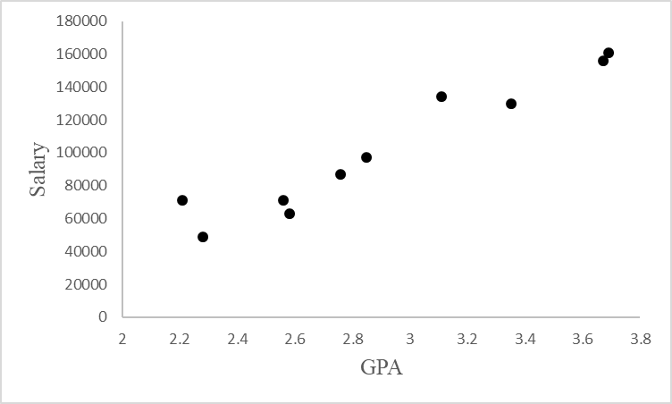

The scatter diagram suggests a positive linear relationship between the two variables.
b. Let x = GPA and y = annual salary ($)
c. SSE = SST = = 14,706.9
Thus, SSR = SST – SSE = 14,706.9 – 1,047.747 = 13,659.15
MSR = SSR/1 = 13,659.15
MSE = SSE/(n – 2) = 1,047.747/8 = 130.9684
F = MSR/MSE = 13,659.15/130.9684 = 104.2935
Using F table (one degree of freedom numerator and eight denominator), p-value is less than 0.01.
Because p-value we reject H₀: β₁ = 0
Salary and GPA are related.
28. Broker Satisfaction Conclusion. In exercise 8, ratings data on x = the quality of the speed of execution and y = overall satisfaction with electronic trades provided the estimated regression equation = 0.2046 + 0.9077x (AAII website). At the 0.05 level of significance, test whether speed of execution and overall satisfaction are related. Show the ANOVA table. What is your conclusion? LO 6, 7
Solutions:
The sum of squares due to error and the total sum of squares are
Thus, SSR = SST – SSE = 3.5800 – 1.4378 = 2.1422
s² = MSE = SSE / (n – 2) = 1.4378/9 = 0.1598
We can use either the t test or F test to determine whether speed of execution and overall satisfaction are related.
We will first illustrate the use of the t test.
Degrees of freedom = n – 2 = 9
Because t > 0, p-value is two times the upper tail area.
Using t table; area in upper tail is less than 0.005; therefore, p-value is less than 0.01.
Using Excel: p-value = 2*(1 – T.DIST(3.66, 9, TRUE)) = 0.0052
Using unrounded Test Statistic via Excel with cell referencing, p-value = 0.0052
Because p-value we reject H₀: = 0
Because we can reject H₀: = 0 we conclude that speed of execution and overall satisfaction are related.
Next, we illustrate the use of the F test.
MSR = SSR/1 = 2.1421
F = MSR/MSE = 2.1421/0.1598 = 13.4
Using F table (one degree of freedom numerator and nine denominator), p-value is less than 0.01.
Using Excel, the p-value = F.DIST.RT(13.4, 1, 9) = 0.0052.
Because p-value we reject H₀: = 0
Because we can reject H₀: = 0 we conclude that speed of execution and overall satisfaction are related.
The ANOVA table is shown below.
Source of Variation | Sum of Squares | Degrees of Freedom | Mean Square | F | p-Value
Regression | 2.1422 | 1 | 2.1422 | 13.4 | 0.0052
Error | 1.4378 | 9 | 0.1598
Total | 3.5800 | 10
29. Cost Estimation Conclusion. Refer to exercise 21, where data on production volume and cost were used to develop an estimated regression equation relating production volume and cost for a particular manufacturing operation. Use α = 0.05 and the F test to determine whether the production volume is significantly related to the total cost. Show the ANOVA table. What is your conclusion? LO 7
Solutions:
SSE =233,333.33 SST == 5,648,333.33
Thus, SSR = SST – SSE = 5,648,333.33 – 233,333.33 = 5,415,000
MSE = SSE/(n – 2) = 233,333.33/(4) = 58,333.33
MSR = SSR/1 = 5,415,000
F = MSR/MSE = 5,415,000/58,333.25 = 92.83
Source of Variation | Sum of Squares | Degrees of Freedom | Mean Square | F | p-Value
Regression | 5,415,000.00 | 1 | 5,415,000 | 92.83 | 0.0006
Error | 233,333.33 | 4 | 58,333.33
Total | 5,648,333.33 | 5
Using F table (one degree of freedom numerator and four denominator), p-value is less
than 0.01.
Using Excel, the p-value = F.DIST.RT(92.83, 1, 4) = 0.0006.
Because p-value we reject H₀: β₁ = 0. Production volume and total cost are related.
We can use either the t test or F test to determine whether variables are related. The solution for the t test is as follows:
Degrees of freedom = n – 2 = 4
Because t > 0, p-value is two times the upper tail area.
Using t table; area in upper tail is less than 0.005; therefore, p-value is less than 0.01.
Using Excel: p-value = 2*(1 – T.DIST(9.63, 4, TRUE)) = 0.0007
Using unrounded Test Statistic via Excel with cell referencing, p-value = 0.0006
Because p-value, we reject H₀: = 0
Because we can reject H₀: = 0 we conclude that production volume and total cost are related
30. Rental Car Revenue and Fleet Size. Companies in the U.S. car rental market vary greatly in terms of the size of the fleet, the number of locations, and annual revenue. The following data were used to investigate the relationship between the number of cars in service (1,000s) and the annual revenue ($ millions) for six smaller car rental companies (Auto Rental News website).
Company | Cars  (1,000s) | Revenue  ($ millions)
U-Save Auto Rental System, Inc. | 11.5 | 118
Payless Car Rental System, Inc. | 10.0 | 135
ACE Rent A Car | 9.0 | 100
Rent-A-Wreck of America | 5.5 | 37
Triangle Rent-A-Car | 4.2 | 40
Affordable/Sensible | 3.3 | 32
With x = cars in service (1,000s) and y = annual revenue ($ millions), the estimated regression equation is = –17.005 + 12.966x. For these data, SSE = 1,043.03 and SST = 10,568. Use the t test to determine whether these results indicate a significant relationship between the number of cars in service and the annual revenue. LO 6
Solutions:
SSE =1,043.03 SST == 10,568
Thus, SSR = SST – SSE = 10,568 – 1,043.03 = 9,524.97
s² = MSE = SSE/(n-2) = 1,043.03/4 = 260.758
= 56.655
Degrees of freedom = n – 2 = 44
Because t > 0, p-value is two times the upper tail area.
Using t table; area in upper tail is less than 0.005; therefore, p-value is less than 0.01.
Using Excel: p-value = 2*(1 – T.DIST(6.04, 4, TRUE)) = 0.0038
Using unrounded Test Statistic via Excel with cell referencing, p-value = 0.0038.
Because p-value we reject H₀: β₁ = 0
There is a significant relationship between cars in service and annual revenue.
We can use either the t test or F test to determine whether variables are related. The solution for the F test is as follows:
Source of Variation | Sum of Squares | Degrees of Freedom | Mean Square | F | p-Value
Regression | 9,524.97 | 1 | 9,524.97 | 36.53 | 0.0038
Error | 1,043.03 | 4 | 260.758
Total | 10,568 | 5
SSE =1,043.03 SST == 10,568
Thus, SSR = SST – SSE = 10,568 – 1,043.03 = 9,524.97
s² = MSE = SSE/(n – 2) = 1,043.03/4 = 260.758
MSR = SSR/1 = 9,524.97
F = MSR/MSE = 9,524.97/260.758 = 36.53
Using F table (one degree of freedom numerator and four denominator), p-value is less than 0.01.
Using Excel, the p-value = F.DIST.RT(36.53, 1, 4) = 0.0038
Because p-value we reject H₀: β₁ = 0. Cars in service and annual revenue are related.
31. Significance of Racing Bike Weight on Price. In exercise 20, data on x = weight (pounds) and y = price ($) for 10 road-racing bikes provided the estimated regression equation
= 28,574 – 1,439x (Bicycling website). For these data SSE = 7,102,922.54 and
SST = 52,120,800. Use the F test to determine whether the weight for a bike and the price are related at the 0.05 level of significance. LO 7
Solutions:
Source of Variation | Sum of Squares | Degrees of Freedom | Mean Square | F | p-Value
Regression | 45,017,877.46 | 1 | 45,017,877.46 | 50.70 | 0.0001
Error | 7,102,922.54 | 8 | 887,865.3
Total | 52,120,800 | 9
SST = 52,120,800 SSE = 7,102,922.54
SSR = SST – SSR = 52,120,800 – 7,102,922.54 = 45,017,877.46
MSR = SSR/1 = 45,017,877.46
MSE = SSE/(n – 2) = 7,102,922.54/8 = 887,865.3
F = MSR/MSE = 45,017,877.46/887,865.3 = 50.7
Using F table (one degree of freedom numerator and eight denominator), p-value is less than 0.01.
Using Excel, the p-value = F.DIST.RT(50.7, 1, 8) = 0.0001
Because p-value we reject H₀: β₁ = 0
Weight and price are related.
Methods
32. The data from exercise one follow. LO 8, 9
x_{i} | 1 | 2 | 3 | 4 | 5
y_{i} | 3 | 7 | 5 | 11 | 14
a. Use equation (14.23) to estimate the standard deviation of when x = 4.
b. Use expression (14.24) to develop a 95% confidence interval for the expected value of y when x = 4.
c. Use equation (14.26) to estimate the standard deviation of an individual value of y when x = 4.
d. Use expression (14.27) to develop a 95% prediction interval for y when x = 4.
Solutions:
a.
s² = MSE = SSE/(n – 2) = 12.4/3 = 4.133
b. = 0.2 + 2.6= 0.2 + 2.6(4) = 10.6
df = n – 2 = 3 t_{a/2} = 3.182
10.6 ± 3.182 (1.114) = 10.6 ± 3.54
or 7.06 to 14.14
c.
d. df = n – 2 = 3 t_{a/2} = 3.182
10.6 ± 3.182 (2.32) = 10.6 ± 7.38
or 3.22 to 17.98
33. The data from exercise two follow. LO 8, 9
x_{i} | 3 | 12 | 6 | 20 | 14
y_{i} | 55 | 40 | 55 | 10 | 15
a. Estimate the standard deviation of when x = 8.
b. Develop a 95% confidence interval for the expected value of y when x = 8.
c. Estimate the standard deviation of an individual value of y when x = 8.
d. Develop a 95% prediction interval for y when x = 8.
Solutions:
a.
s² = MSE = SSE/(n – 2) = 230/3 = 76.667
b.
df = n – 2 = 3 t_{a/2} = 3.182
44 ± 3.182 (4.3780) = 44 ± 13.93
or 30.07 to 57.93
c.
d. df = n – 2 = 3 t_{a/2} = 3.182
44 ± 3.182(9.7895) = 44 ± 31.15
or 12.85 to 75.15
34. The data from exercise three follow. LO 8, 9
x_{i} | 2 | 6 | 9 | 13 | 20
y_{i} | 7 | 18 | 9 | 26 | 23
Develop the 95% confidence and prediction intervals when x = 12. Explain why these two intervals are different.
Solutions:
s² = MSE = SSE/(n – 2) = 127.3/3 = 42.433
df = n – 2 = 3 t_{α/2} = 3.182
18.40 ± 3.182(3.063) = 18.40 ± 9.75
or 8.65 to 28.15
df = n – 2 = 3 t_{α/2} = 3.182
18.40 ± 3.182(7.198) = 18.40 ± 22.90
or –4.50 to 41.30
The two intervals are different because there is more variability associated with predicting an individual value than there is a mean value.
Applications
35. Restaurant Lines. Many small restaurants in Portland, Oregon, and other cities across the United States do not take reservations. Owners say that with smaller capacity, noshows are costly, and they would rather have their staff focused on customer service rather
than maintaining a reservation system (pressherald.com). However, it is important to be able to give reasonable estimates of waiting time when customers arrive and put their name
on the waiting list. The file restaurantline contains 10 observations of number of people
in line ahead of a customer (independent variable x) and actual waiting time (dependent variable y). The estimated regression equation is:
= 4.35 + 8.81x and MSE = 94.42. LO 2, 8, 9
a. Develop a point estimate for a customer who arrives with three people on the wait-list.
b. Develop a 95% confidence interval for the mean waiting time for a customer who arrives with three customers already in line.
c. Develop a 95% prediction interval for Roger and Sherry Davy’s waiting time if there are three customers in line when they arrive.
d. Discuss the difference between parts (b) and (c).
Solutions:
a.
b.
30.8 ± 2.306 (4.11) = 30.8 ± 9.48
or 21.32 to 40.28
c.
30.8 ± 2.306 (10.55) = 30.8 ± 24.33
or 6.47 to 55.13
d. As expected, the prediction interval is much wider than the confidence interval. This is due to the fact that it is more difficult to predict the waiting time for an individual customer arriving with three people in line than it is to estimate the mean waiting time for a customer arriving with three people in line.
36. Sales Performance. In exercise seven, the data on y = annual sales ($1,000s) for new customer accounts and x = number of years of experience for a sample of 10 salespersons provided the estimated regression equation = 80 + 4x. For these data = 7, Σ(x_{i} – )² = 142, and s = 4.6098. LO 8, 9
a. Develop a 95% confidence interval for the mean annual sales for all salespersons with nine years of experience.
b. The company is considering hiring Tom Smart, a salesperson with nine years of experience. Develop a 95% prediction interval of annual sales for Tom Smart.
c. Discuss the differences in your answers to parts (a) and (b).
Solutions:
a.
df = n – 2 = 8 t_{a/2} = 2.306
116 ± 2.306(1.6503) = 116 ± 3.806
or 112.194 to 119.806 ($112,194 to $119,806)
b.
df = n – 2 = 8 t_{a/2} = 2.306
116 ± 2.306(4.8963) = 116 ± 11.291
or 104.709 to 127.291 ($104,709 to $127,291)
c. As expected, the prediction interval is much wider than the confidence interval. This is due to the fact that it is more difficult to predict annual sales for one new salesperson with nine years of experience than it is to estimate the mean annual sales for all salespersons with nine years of experience.
37. Auditing Itemized Deductions. In exercise 13, data were given on the adjusted gross income x and the amount of itemized deductions taken by taxpayers. Data were reported in thousands of dollars. With the estimated regression equation = 4.68 + 0.16x, the point estimate of a reasonable level of total itemized deductions for a taxpayer with an adjusted gross income of $52,500 is $13,080. LO 8, 9
a. Develop a 95% confidence interval for the mean amount of total itemized deductions for all taxpayers with an adjusted gross income of $52,500.
b. Develop a 95% prediction interval estimate for the amount of total itemized deductions for a particular taxpayer with an adjusted gross income of $52,500.
c. If the particular taxpayer referred to in part (b) claimed total itemized deductions of $20,400, would the IRS agent’s request for an audit appear to be justified?
d. Use your answer to part (b) to give the IRS agent a guideline as to the amount of total itemized deductions a taxpayer with an adjusted gross income of $52,500 should claim before an audit is recommended.
Solutions:
a.
s² = 1.88 s = 1.37
= 4.68 + 0.16= 4.68 + 0.16(52.5) = 13.08
13.08 ± 2.571 (0.52) = 13.08 ± 1.34
or 11.74 to 14.42 or $11,740 to $14,420
b. = 1.47
13.08 ± 2.571 (1.47) = 13.08 ± 3.78
or 9.30 to 16.86 or $9,300 to $16,860
c. Yes, $20,400 is much larger than anticipated.
d. Any deductions exceeding the $16,860 upper limit could suggest an audit.
38. Prediction Intervals for Cost Estimation. Refer to exercise 21, where data on the production volume x and total cost y for a particular manufacturing operation were used to develop the estimated regression equation = 1,246.67 + 7.6x. LO 2, 9
a. The company’s production schedule shows that 500 units must be produced next month. Predict the total cost for next month.
b. Develop a 99% prediction interval for the total cost for next month.
c. If an accounting cost report at the end of next month shows that the actual production cost during the month was $6,000, should managers be concerned about incurring such a high total cost for the month? Discuss.
Solutions:
a. = 1,246.67 + 7.6(500) = $5,046.67
b.
s² = MSE = SSE/(n – 2) = 233,333.33/4 = 58,333.33
df = n – 2 = 4 t_{α/2} = 4.604
5,046.67 ± 4.604 (267.50) = 5,046.67 ± 1,231.57 (or 5,046.667 ± 1,231.564 from unrounded)
or $3,815.10 to $6,278.24 (or $3,815.10 to $6,278.23 from unrounded)
c. Based on one month, $6,000 is not out of line since $3,815.10 to $6,278.24 is the prediction interval. However, a sequence of five to seven months with consistently high costs should cause concern.
39. Entertainment Spend. The Wall Street Journal asked Concur Technologies, Inc., an expense management company, to examine data from 8.3 million expense reports to provide insights regarding business travel expenses. Their analysis of the data showed that New York was the most expensive city. The following table shows the average daily hotel room rate (x) and the average amount spent on entertainment (y) for a random sample of nine of the 25 most-visited U.S. cities. These data lead to the estimated regression equation = 17.49 + 1.0334x. For these data, SSE = 1,541.4. LO 2,8,9.
City | Room Rate  ($) | Entertainment  ($)
Boston | 148 | 161
Denver | 96 | 105
Nashville | 91 | 101
New Orleans | 110 | 142
Phoenix | 90 | 100
San Diego | 102 | 120
San Francisco | 136 | 167
San Jose | 90 | 140
Tampa | 82 | 98
a. Predict the amount spent on entertainment for a particular city that has a daily room rate of $89.
b. Develop a 95% confidence interval for the mean amount spent on entertainment for all cities that have a daily room rate of $89.
c. The average room rate in Chicago is $128. Develop a 95% prediction interval for the amount spent on entertainment in Chicago.
Solutions:
a. With = 89,
b. s² = MSE = SSE/(n – 2) = 1,541.4/7 = 220.2
109.46 ± 2.365(6.1819) = 109.46 ± 14.6202
or $94.84 to $124.08
c.
149.77 ± 2.365(16.525) = 149.77 ± 39.08
or $110.69 to $188.85
Applications
40. Apartment Selling Price. The commercial division of a real estate firm conducted a study to determine the extent of the relationship between annual gross rents ($1,000s) and the selling price ($1,000s) for apartment buildings. Data were collected on several properties sold, and Excel’s Regression tool was used to develop an estimated regression equation. A portion of the regression output follows. LO 1, 2, 7
a. How many apartment buildings were in the sample?
ANOVA
 | df | SS | MS | F | Significance F
Regression | 1 | 41,587.3
Residual | 7
Total | 8 | 51,984.1

 | Coefficients | Standard Error | t Stat | P-value
Intercept | 20.000 | 3.2213 | 6.21
Annual Gross Rents | 7.210 | 1.3626 | 5.29
b. Write the estimated regression equation.
c. Use the t test to determine whether the selling price is related to annual gross rents. Use α = 0.05.
d. Use the F test to determine whether the selling price is related to annual gross rents. Use α = 0.05.
e. Predict the selling price of an apartment building with gross annual rents of $50,000.
Solutions:
a. Total df = n – 1. Therefore 8 = n – 1 and n = 9
b.
c. Using the t stat for β₁ (coefficient of x variable), t = 5.29
Degrees of freedom = n – 2 = 7
Because t > 0, p-value is two times the upper tail area.
Using t table; area in upper tail is less than 0.005; therefore, p-value is less than 0.01.
Using Excel: p-value = 2*(1 – T.DIST(5.29, 7, TRUE)) = 0.0011
Because p-value we reject H₀: β₁ = 0
d. SSE = SST – SSR = 51,984.1 – 41,587.3 = 10,396.8
MSE = SSE/(n – 2) = 10,396.8/7 = 1,485.26
MSR = SSR/1 = 41,587.26
F = MSR/MSE = 41,587.3/1,485.3 = 28.00
From the F table (one degree of freedom numerator and seven denominator), p-value is less than 0.01.
Using Excel, p-value = F.DIST.RT(28, 1, 7) = 0.0011
Because p-value we reject H₀: ₁ = 0.
e. or $380,500
41. Computer Maintenance. Following is a portion of the regression output for an application relating maintenance expense (dollars per month) to usage (hours per week) for a particular brand of computer terminal. LO 1, 2, 6
ANOVA
 | df | SS | MS | F | Significance F
Regression | 1 | 1,575.76
Residual | 8 | 349.14
Total | 9 | 1,924.90

 | Coefficients | Standard Error | t Stat | P-value
Intercept | 6.1092 | 0.9361
Usage | 0.8951 | 0.149
a. Write the estimated regression equation.
b. Use a t test to determine whether monthly maintenance expense is related to usage at the 0.05 level of significance.
c. Did the estimated regression equation provide a good fit? Explain.
Solutions:
a.
b.
Degrees of freedom = n – 2 = 8
Because t > 0, p-value is two times the upper tail area.
Using t table; area in upper tail is less than 0.005; therefore, p-value is less than 0.01.
Using Excel: p-value = 2*(1 – T.DIST(6.01, 8, TRUE)) = 0.0003
Because p-value we reject H₀: β₁ = 0; monthly maintenance expense is related to usage.
c. r² = SSR/SST = 1,575.76/1,924.90 = 0.82. A good fit.
42. Annual Sales and Salespeople. A regression model relating the number of salespersons at a branch office to annual sales at the office (in thousands of dollars) provided the following regression output. LO 1, 2, 7
ANOVA
 | df | SS | MS | F | Significance F
Regression | 1 | 6,828.6
Residual | 28
Total | 29 | 9,127.4

 | Coefficients | Standard Error | t Stat | P-value
Intercept | 80.0 | 11.333
 | 50.0 | 5.482
a. Write the estimated regression equation.
b. Compute the F statistic and test the significance of the relationship at the 0.05 level of significance.
c. Compute the t statistic and test the significance of the relationship at the 0.05 level of significance.
d. Predict the annual sales at the Memphis branch office. This branch employs
12 salespersons.
Solutions:
a. = 80.0 + 50.0x
b. SSE = SST – SSR = 9,127.4 – 6,826.6 = 2,300.8
MSE = SSE/(n – 2) = 2,300.8/28 = 82.17
MSR = SSR/1 = 6,828.6
F = MSR/MSE = 6,828.6/82.17 = 83.1
From the F table (one degree of freedom numerator and 28 denominator), p-value is less than 0.01.
Using Excel, p-value = F.DIST.RT(83.1, 1, 28) = 0
Because p-value we reject H₀: β₁ = 0.
Branch office sales are related to the salespersons.
c. t == 9.12
Degrees of freedom = n – 2 = 28
Because t > 0, p-value is two times the upper tail area
Using t table; area in upper tail is less than 0.005; therefore, p-value is less than 0.01.
Using Excel: p-value = 2*(1 – T.DIST(9.12, 28, TRUE)) = 0
Because p-value we reject H₀: β₁ = 0
d. or $680,000
43. Estimating Setup Time. Sherry is a production manager for a small manufacturing shop and is interested in developing a predictive model to estimate the time to produce an order of a given size—that is, the total time to produce a certain quantity of the product. She has collected data on the total time to produce 30 different orders of various quantities in the file setup. LO 1, 3, 4, 6
a. Develop a scatter diagram with quantity as the independent variable.
b. What does the scatter diagram developed in part (a) indicate about the relationship between the two variables?
c. Develop the estimated regression equation. Interpret the intercept and slope.
d. Test for a significant relationship. Use 0.05.
e. Did the estimated regression equation provide a good fit?

Solutions:
a.

b. There appears to be a positive linear relationship between the two variables.
c. The Excel output follows:
SUMMARY OUTPUT
Regression Statistics
Multiple R | 0.8179
R Square | 0.6689
Adjusted R Square | 0.6571
Standard Error | 85.5885
Observations | 30

ANOVA
 | df | SS | MS | F | Significance F
Regression | 1 | 414397.88 | 414397.88 | 56.57 | 0.00
Residual | 28 | 205110.82 | 7325.39
Total | 29 | 619508.70
 | Coefficients | Standard Error | t Stat | P-value | Lower 95% | Upper 95%
Intercept | 117.5419 | 38.4893 | 3.0539 | 0.0049 | 38.7003 | 196.3836
Quantity | 0.7631 | 0.1015 | 7.5213 | 0.0000 | 0.5553 | 0.9710
= 0.7631(Quantity) + 117.5419

The intercept is the estimate for the setup time (117.5 minutes) and the slope
(0.7631 minutes) is the production time per unit.
- Significant relationship: p-value = 0.000 < α = 0.05.
e. = 0.6689; a good fit.
44. Auto Racing Helmet. Automobile racing, high-performance driving schools, and driver education programs run by automobile clubs continue to grow in popularity. All these activities require the participant to wear a helmet that is certified by the Snell Memorial Foundation, a not-for-profit organization dedicated to research, education, testing, and development of helmet safety standards. Snell “SA” (Sports Application) rated professional helmets are designed for auto racing and provide extreme impact resistance and high fire protection. One of the key factors in selecting a helmet is weight, since lower-weight helmets tend to place less stress on the neck. The following data show the weight and price for 18 SA helmets (SoloRacer website). LO 1, 4, 6
Helmet | Weight (oz) | Price ($)
Pyrotect Pro Airflow | 64 | 248
Pyrotect Pro Airflow Graphics | 64 | 278
RCi Full Face | 64 | 200
RaceQuip RidgeLine | 64 | 200
HJC AR-10 | 58 | 300
HJC Si-12 | 47 | 700
HJC HX-10 | 49 | 900
Impact Racing Super Sport | 59 | 340
Zamp FSA-1 | 66 | 199
Zamp RZ-2 | 58 | 299
Zamp RZ-2 Ferrari | 58 | 299
Zamp RZ-3 Sport | 52 | 479
Zamp RZ-3 Sport Painted | 52 | 479
Bell M2 | 63 | 369
Bell M4 | 62 | 369
Bell M4 Pro | 54 | 559
G Force Pro Force 1 | 63 | 250
G Force Pro Force 1 Grafx | 63 | 280
a. Develop a scatter diagram with weight as the independent variable.
b. Does there appear to be any relationship between these two variables?
c. Develop the estimated regression equation that could be used to predict the price given the weight.
d. Test for the significance of the relationship at the 0.05 level of significance.
e. Did the estimated regression equation provide a good fit? Explain.

Solutions:
a. Scatter diagram:

b. There appears to be a negative linear relationship between the two variables. The heavier helmets tend to be less expensive.
c. Using the file racehelmets and Excel’s Descriptive Statistics Regression Tool, the Excel output is shown below:
Regression Statistics
Multiple R | 0.8800
R Square | 0.7743
Adjusted R Square | 0.7602
Standard Error | 91.8098
Observations | 18
ANOVA
 | df | SS | MS | F | Significance F
Regression | 1 | 462761.145 | 462761.15 | 54.9008 | 1.47771E-06
Residual | 16 | 134864.6328 | 8429.0395
Total | 17 | 597625.7778
 | Coefficients | Standard Error | t Stat | P-value | Lower 95% | Upper 95%
Intercept | 2044.3809 | 226.3543 | 9.0318 | 1.111E-07 | 1564.5313 | 2524.2306
Weight | –28.3499 | 3.8261 | –7.4095 | 1.478E-06 | –36.4609 | –20.2388
= 2,044.38 – 28.35 Weight
d. From the Excel output for both the F test and the t test on β₁ (coefficient of x), there is evidence of a significant relationship: p-value = 0.000 < α = 0.05.
e. r² = 0.774; a good fit.
Methods
45. Given are data for two variables, x and y. LO 1, 10
x_{i} | 6 | 11 | 15 | 18 | 20
y_{i} | 6 | 8 | 12 | 20 | 30
a. Develop an estimated regression equation for these data.
b. Compute the residuals.
c. Develop a plot of the residuals against the independent variable x. Do the assumptions about the error terms seem to be satisfied?
d. Compute the standardized residuals.
e. Develop a plot of the standardized residuals against What conclusions can you draw from this plot?
Solutions:
a.
Using Excel’s Descriptive Statistics Regression Tool, the Excel output is shown below:
SUMMARY OUTPUT
Regression Statistics
Multiple R | 0.903611
R Square | 0.816513
Adjusted R Square | 0.755351
Standard Error | 4.876463
Observations | 5
ANOVA
 | df | SS | MS | F | Significance F
Regression | 1 | 317.4603 | 317.4603 | 13.34995 | 0.035399161
Residual | 3 | 71.33968 | 23.77989
Total | 4 | 388.8
 | Coefficients | Standard Error | t Stat | p-Value
Intercept | –7.02222 | 6.461186 | –1.08683 | 0.356632
X Variable 1 | 1.587302 | 0.43443 | 3.653758 | 0.035399
b. Residual = y –
Computing each for each x or inputting the data into Excel and using the Residuals option in Excel’s Descriptive Statistics Regression Tool results in the following residuals:
x | y |  | Residual y –
6 | 6 | 2.5016 | 3.4984
11 | 8 | 10.4381 | –2.4381
15 | 12 | 16.7873 | –4.7873
18 | 20 | 21.5492 | –1.5492
20 | 30 | 24.7238 | 5.2762
c.

With only five observations it is difficult to determine if the assumptions are satisfied. However, the plot does suggest curvature in the residuals that would indicate that the error term assumptions are not satisfied. The scatter diagram for these data also indicates that the underlying relationship between x and y may be curvilinear.
d. Using equations (14.30) and (14.32) from the text to compute the standardized residual:
Standardized residual_{i} =
x | y |  | Residual y – | h | Standardized residual
6 | 6 | 2.5016 | 3.4984 | 0.7079 | 1.3275
11 | 8 | 10.4381 | –2.4381 | 0.2714 | –0.5857
15 | 12 | 16.7873 | –4.7873 | 0.2079 | –1.1031
18 | 20 | 21.5492 | –1.5492 | 0.3270 | –0.3873
20 | 30 | 24.7238 | 5.2762 | 0.4857 | 1.5087
Alternatively, as discussed in Section 14.8, Excel’s Descriptive Statistics Regression Tool calculates a standard (vs standardized) residual that appears different (especially for smaller samples) but which will generally have little effect on the pattern observed.
The results of the standard residuals as calculated by Excel are as follows:
RESIDUAL OUTPUT
Observation | Predicted Y | Residuals | Standard Residuals
1 | 2.501587302 | 3.498413 | 0.828391149
2 | 10.43809524 | –2.4381 | –0.57731797
3 | 16.78730159 | –4.7873 | –1.133587889
4 | 21.54920635 | –1.54921 | –0.36683746
5 | 24.72380952 | 5.27619 | 1.249352169
e. The standardized residual plot has the same shape as the original residual plot. The curvature observed indicates that the assumptions regarding the error term may not be satisfied.
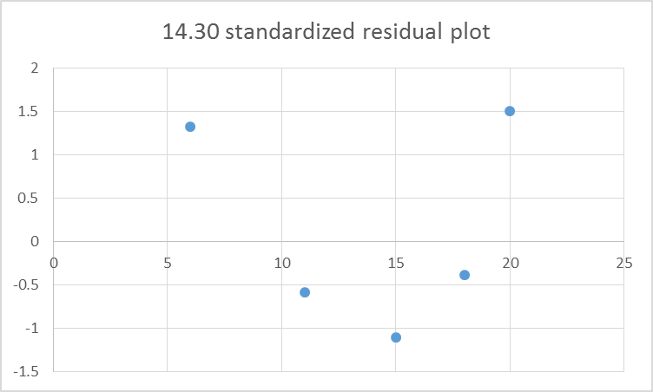

46. The following data were used in a regression study. LO 1, 10
Observation | x_{i} | y_{i} |  | Observation | x_{i} | y_{i}
1 | 2 | 4 |  | 6 | 7 | 6
2 | 3 | 5 |  | 7 | 7 | 9
3 | 4 | 4 |  | 8 | 8 | 5
4 | 5 | 6 |  | 9 | 9 | 11
5 | 7 | 4
a. Develop an estimated regression equation for these data.
b. Construct a plot of the residuals. Do the assumptions about the error term seem to be satisfied?
Solutions:
a. Using Excel’s Descriptive Statistics Regression Tool, the Excel output is shown below:
SUMMARY OUTPUT
Regression Statistics
Multiple R | 0.620164219
R Square | 0.384603659
Adjusted R Square | 0.296689895
Standard Error | 2.054229935
Observations | 9
ANOVA
 | df | SS | MS | F | Significance F
Regression | 1 | 18.46097561 | 18.46098 | 4.374783 | 0.074793318
Residual | 7 | 29.53902439 | 4.219861
Total | 8 | 48
 | Coefficients | Standard Error | t Stat | p-Value
Intercept | 2.32195122 | 1.88710113 | 1.230433 | 0.258275
X Variable 1 | 0.636585366 | 0.304353556 | 2.091598 | 0.074793
b. From Excel’s Data Analysis Regression Tool using the residual output:
RESIDUAL OUTPUT
Observation | Predicted Y | Residuals
1 | 3.595121951 | 0.404878049
2 | 4.231707317 | 0.768292683
3 | 4.868292683 | –0.868292683
4 | 5.504878049 | 0.495121951
5 | 6.77804878 | –2.77804878
6 | 6.77804878 | –0.77804878
7 | 6.77804878 | 2.22195122
8 | 7.414634146 | –2.414634146
9 | 8.051219512 | 2.948780488

The assumption that the variance is the same for all values of x is questionable. The variance appears to increase for larger values of x.
Applications
47. Restaurant Advertising and Revenue. Data on advertising expenditures and revenue (in thousands of dollars) for the Four Seasons Restaurant follow. LO 1, 7, 10
Advertising Expenditures | Revenue
1 | 19
2 | 32
4 | 44
6 | 40
10 | 52
14 | 53
20 | 54
a. Let x equal advertising expenditures and y equal revenue. Use the method of least squares to develop a straight line approximation of the relationship between the two variables.
b. Test whether revenue and advertising expenditures are related at a 0.05 level of significance using the F test.
c. Prepare a residual plot of y – versus Use the result from part (a) to obtain the values of
d. What conclusions can you draw from residual analysis? Should this model be used, or should we look for a better one?
Solutions:
Using Excel’s Descriptive Statistics Regression Tool, the Excel output is shown below:
SUMMARY OUTPUT
Regression Statistics
Multiple R | 0.830868141
R Square | 0.690341868
Adjusted R Square | 0.628410242
Standard Error | 7.87753068
Observations | 7
ANOVA
 | df | SS | MS | F | Significance F
Regression | 1 | 691.7225519 | 691.7226 | 11.14684 | 0.020582051
Residual | 5 | 310.2774481 | 62.05549
Total | 6 | 1,002
 | Coefficients | Standard Error | t Stat | p-Value
Intercept | 29.39910979 | 4.807253405 | 6.115573 | 0.001695
X Variable 1 | 1.547477745 | 0.463498729 | 3.338688 | 0.020582
a. Let x = advertising expenditures and y = revenue
b. SST = 1,002 SSE = 310.28 SSR = 691.72
MSR = SSR/1 = 691.72
MSE = SSE/(n – 2) = 310.28/5 = 62.06
F = MSR/MSE = 691.72/62.06= 11.15
Using F table (one degree of freedom numerator and five denominator), p-value is between 0.01 and 0.025.
Using Excel, the p-value = F.DIST.RT(11.15, 1, 5) = 0.0206
Because p-value = 0.05, we conclude that the two variables are related.
Additionally, from the Excel output for both the F test with F stat = 11.15 and the t test on β₁ (coefficient of x) with a t stat = 3.34, there is evidence of a significant relationship: p-value = 0.0206 < α = 0.05.
c.

d. The residual plot leads us to question the assumption of a linear relationship between x and y. Even though the relationship is significant at the 0.05 level of significance, it would be extremely dangerous to extrapolate beyond the range of the data.
48. Experience and Sales. Refer to exercise 7, where an estimated regression equation relating years of experience and annual sales was developed. LO 10
a. Compute the residuals and construct a residual plot for this problem.
b. Do the assumptions about the error terms seem reasonable in light of the residual plot?
Solutions:
Using Excel’s Descriptive Statistics Regression Tool, the Excel output is shown below:
SUMMARY OUTPUT
Regression Statistics
Multiple R | 0.964564633
R Square | 0.93038493
Adjusted R Square | 0.921683047
Standard Error | 4.609772229
Observations | 10
ANOVA
 | df | SS | MS | F | Significance F
Regression | 1 | 2272 | 2272 | 106.9176471 | 6.60903E-06
Residual | 8 | 170 | 21.25
Total | 9 | 2442
 | Coefficients | Standard Error | t Stat | p-Value
Intercept | 80 | 3.075344937 | 26.01334 | 5.12002E-09
X Variable 1 | 4 | 0.386843492 | 10.3401 | 6.60903E-06
a.
RESIDUAL OUTPUT
Observation | Predicted Y | Residuals
1 | 84 | –4
2 | 92 | 5
3 | 96 | –4
4 | 96 | 6
5 | 104 | –1
6 | 112 | –1
7 | 120 | –1
8 | 120 | 3
9 | 124 | –7
10 | 132 | 4

b. The assumptions concerning the error term appear reasonable.
49. Cost of Living Index. The file costliving contains the cost of living indexes and the population densities (number of people per square mile) for 61 cities in the United States. The cost of living index measures the cost of living in a particular city relative to the cost of living in New York City. San Francisco has an index of 112.15, meaning that it is 12.15% more expensive to live in San Francisco than New York City. Washington, DC, has an index of 84.64, which means that the cost to live in Washington, DC, is only 84.64% of what it costs to live in New York City (Numbeo website). LO 1, 10
a. Develop the estimated regression equation that can be used to predict the cost of living index for a U.S. city, given the city’s population density.
b. Construct a residual plot against the independent variable.
c. Review the residual plot constructed in part (b). Do the assumptions of the error term and model form seem reasonable?
Solutions:
a. Using the file costliving and Excel’s Descriptive Statistics Regression Tool, a portion of the Excel output follows:
Regression Statistics
Multiple R | 0.8092
R Square | 0.6549
Adjusted R Square | 0.6490
Standard Error | 7.3131
Observations | 61.0000
ANOVA
 | df | SS | MS | F | Significance F
Regression | 1 | 5987.2570 | 5987.2570 | 111.9497 | 2.97466E-15
Residual | 59 | 3155.4186 | 53.4817
Total | 60 | 9142.6756
 | Coefficients | Standard Error | t Stat | p-Value
Intercept | 47.0160 | 1.4216 | 33.0729 | 8.78773E-40
Density | 0.0024 | 0.0002 | 10.5806 | 2.97466E-15
= 47.016 + 0.0024 (Density)
b.

c. The residual plot leads us to question the assumption of constant variance of the error terms. The plot indicates that the absolute value of the residuals is larger for larger values of the independent variable (see panel B in Figure 14.16).
Methods
50. Consider the following data for two variables, x and y. LO 11
x_{i} | 135 | 110 | 130 | 145 | 175 | 160 | 120
y_{i} | 145 | 100 | 120 | 120 | 130 | 130 | 110
a. Develop a scatter diagram for these data. Does the scatter diagram indicate any outliers in the data? In general, what implications does this finding have for simple linear regression?
b. Compute the standardized residuals for these data. Do the data include any outliers? Explain.

Solutions:
a. The scatter diagram is shown below:

The scatter diagram indicates that the first observation (x = 135, y = 145) may be an outlier. For simple linear regression the scatter diagram can be used to check for possible outliers.
b. Using Excel’s Descriptive Statistics Regression Tool, the Excel output is shown below:
SUMMARY OUTPUT
Regression Statistics
Multiple R | 0.620115502
R Square | 0.384543235
Adjusted R Square | 0.261451882
Standard Error | 12.61505192
Observations | 7
ANOVA
 | df | SS | MS | F | Significance F
Regression | 1 | 497.1594684 | 497.1594684 | 3.124047515 | 0.137389804
Residual | 5 | 795.6976744 | 159.1395349
Total | 6 | 1292.857143
 | Coefficients | Standard Error | t Stat | p-Value
Intercept | 66.10465116 | 32.06135318 | 2.061817254 | 0.09421512
X Variable 1 | 0.402325581 | 0.22762441 | 1.767497529 | 0.137389804
Using equations (14.30) and (14.32) from the text to compute the standardized residual:
Residual = y –
= leverage
Standardized residual_{i} =
x | y |  | Residual y – | h | Standardized residual
135 | 145 | 120.4186 | 24.5814 | 0.1488 | 2.1121
110 | 100 | 110.3605 | –10.3605 | 0.4221 | –1.0803
130 | 120 | 118.4070 | 1.5930 | 0.1709 | 0.1387
145 | 120 | 124.4419 | –4.4419 | 0.1535 | –0.3827
175 | 130 | 136.5116 | –6.5116 | 0.5581 | -0.7765
160 | 130 | 130.4767 | –0.4767 | 0.2826 | -–0.0446
120 | 110 | 114.3837 | –4.3837 | 0.2640 | –0.4050
Alternatively, as discussed in Section 14.8, Excel’s Descriptive Statistics Regression Tool calculates a standard (vs standardized) residual that appears different (especially for smaller samples) but which will generally have little effect on the pattern observed.
The results of the standard residuals as calculated by Excel are as follows:
RESIDUAL OUTPUT
Observation | Predicted Y | Residuals | Standard Residuals
1 | 120.4186047 | 24.58139535 | 2.13455875
2 | 110.3604651 | –10.36046512 | –0.899665017
3 | 118.4069767 | 1.593023256 | 0.138332331
4 | 124.4418605 | –4.441860465 | –0.385714968
5 | 136.5116279 | –6.511627907 | –0.565446027
6 | 130.4767442 | –0.476744186 | –0.041398727
7 | 114.3837209 | –4.38372093 | –0.380666343
Because the standard residual for the first observation is greater than 2, it is considered to be an outlier.
51. Consider the following data for two variables, x and y. LO 11
x_{i} | 4 | 5 | 7 | 8 | 10 | 12 | 12 | 22
y_{i} | 12 | 14 | 16 | 15 | 18 | 20 | 24 | 19
a. Develop a scatter diagram for these data. Does the scatter diagram indicate any influential observations? Explain.
b. Compute the standardized residuals for these data. Do the data include any outliers? Explain.
c. Compute the leverage values for these data. Does there appear to be any influential observations in these data? Explain.
Solutions:
a. The scatter diagram is shown below:

The observation x = 22, y = 19 appears to be an influential observation.
b. Using Excel’s Descriptive Statistics Regression Tool, the Excel output is shown below:
SUMMARY OUTPUT
Regression Statistics
Multiple R | 0.633846348
R Square | 0.401761193
Adjusted R Square | 0.302054725
Standard Error | 3.181227199
Observations | 8
ANOVA
 | df | SS | MS | F | Significance F
Regression | 1 | 40.77876106 | 40.77876106 | 4.029439627 | 0.091490263
Residual | 6 | 60.72123894 | 10.12020649
Total | 7 | 101.5
 | Coefficients | Standard Error | t Stat | p-Value
Intercept | 13.00221239 | 2.396454315 | 5.425604113 | 0.001624201
X Variable 1 | 0.424778761 | 0.211612086 | 2.007346414 | 0.091490263
Using equations (14.30) and (14.32) from the text to compute the standardized residual:
Residual = y –
= leverage
Standardized residual_{i} =
x | y |  | Residual y – | h | Standardized residual
4 | 12 | 14.7013 | –2.7013 | 0.2843 | –1.0037
5 | 14 | 15.1261 | –1.1261 | 0.2356 | –0.4049
7 | 16 | 15.9757 | 0.0243 | 0.1648 | 0.0084
8 | 15 | 16.4004 | –1.4004 | 0.1427 | –0.4754
10 | 18 | 17.2500 | 0.7500 | 0.1250 | 0.2520
12 | 20 | 18.0996 | 1.9004 | 0.1427 | 0.6452
12 | 24 | 18.0996 | 5.9004 | 0.1427 | 2.0032
22 | 19 | 22.3473 | –3.3473 | 0.7622 | –2.1576
Alternatively, as discussed in Section 14.8, Excel’s Descriptive Statistics Regression Tool calculates a standard (vs standardized) residual that appears different (especially for smaller samples) but which will generally have little effect on the pattern observed.
The results of the standard residuals as calculated by Excel are as follows:
RESIDUAL OUTPUT
Observation | Predicted Y | Residuals | Standard Residuals
1 | 14.70132743 | –2.701327434 | –0.917182874
2 | 15.12610619 | –1.126106195 | –0.382347324
3 | 15.97566372 | 0.024336283 | 0.008262909
4 | 16.40044248 | –1.400442478 | –0.475492842
5 | 17.25 | 0.75 | 0.254647825
6 | 18.09955752 | 1.900442478 | 0.645258058
7 | 18.09955752 | 5.900442478 | 2.003379792
8 | 22.34734513 | –3.347345133 | –1.136525544
Using Excel, the standardized residuals are –0.92, –0.38, 0.01, –0.48, 0.25, 0.65, 2.00, and –1.14. The observation x = 12, y = 24 has a standardized residual of 2.00, and is thus very close to being classified as an outlier. The standardized residual values from the textbook calculation also show the last observation with a standardized residual of less than –2; however, it is a result of the large leverage value and is considered an influential observation as shown in part (c).
c. Using Excel we obtained the following leverage values, which are shown in part (b) as values of h:
0.28, 0.24, 0.16, 0.14, 0.13, 0.14, 0.14, 0.76
If the leverage for an observation is greater than 6/n = 6/8 = 0.75, it is considered to have high leverage. Because the leverage for observation x = 22, y = 19 is 0.76, this observation is considered to have high leverage. Thus, we would conclude that observation eight is an influential observation.
Applications
52. Predicting Charity Expenses. Charity Navigator is America’s leading independent charity evaluator. The following data show the total expenses ($), the percentage of the total budget spent on administrative expenses, the percentage spent on fundraising, and the percentage spent on program expenses for 10 supersized charities (Charity Navigator website). Administrative expenses include overhead, administrative staff and associated costs, and organizational meetings. Fundraising expenses are what a charity spends to raise money, and program expenses are what the charity spends on the programs and services it exists to deliver. The sum of the three percentages does not add to 100% because of rounding. LO 1, 3, 11
Charity | Total Expenses  ($) | Administrative  Expenses  (%) | Fundraising  Expenses  (%) | Program  Expenses  (%)
American Red Cross | 3,354,177,445 | 3.9 | 3.8 | 92.1
World Vision | 1,205,887,020 | 4.0 | 7.5 | 88.3
Smithsonian Institution | 1,080,995,083 | 23.5 | 2.6 | 73.7
Food For The Poor | 1,050,829,851 | 0.7 | 2.4 | 96.8
American Cancer Society | 1,003,781,897 | 6.1 | 22.2 | 71.6
Volunteers of America | 929,158,968 | 8.6 | 1.9 | 89.4
Dana-Farber Cancer Institute | 877,321,613 | 13.1 | 1.6 | 85.2
AmeriCares | 854,604,824 | 0.4 | 0.7 | 98.8
ALSAC—St. Jude Children’s Research Hospital | 829,662,076 | 9.6 | 16.9 | 73.4
City of Hope | 736,176,619 | 13.7 | 3.0 | 83.1
a. Develop a scatter diagram with fundraising expenses (%) on the horizontal axis and program expenses (%) on the vertical axis. Looking at the data, do there appear to be any outliers and/or influential observations?
b. Develop an estimated regression equation that could be used to predict program expenses (%) given fundraising expenses (%).
c. Does the value for the slope of the estimated regression equation make sense in the context of this problem situation?
d. Use residual analysis to determine whether any outliers and/or influential observations are present. Briefly summarize your findings and conclusions.
Solutions:
a.

The scatter diagram does indicate potential influential observations. For example, the 22.2% fundraising expense for the American Cancer Society and the 16.9% fundraising expense for the St. Jude Children’s Research Hospital look like they may each have a large influence on the slope of the estimated regression line. And, with a fundraising expense of on 2.6%, the percentage spent on programs and services by the Smithsonian Institution (73.7%) seems to be somewhat lower than would be expected; thus, this observeraton may need to be considered as a possible outlier.
b. Using the file charities and Excel’s Descriptive Statistics Regression Tool, a portion of the Excel output follows:
Regression Statistics
Multiple R | 0.6910
R Square | 0.4775
Adjusted R Square | 0.4122
Standard Error | 7.4739
Observations | 10
ANOVA
 | df | SS | MS | F | Significance F
Regression | 1 | 408.3547 | 408.3547 | 7.3105 | 0.0269
Residual | 8 | 446.8693 | 55.8587
Total | 9 | 855.224
 | Coefficients | Standard Error | t Stat | p-Value
Intercept | 90.9815 | 3.1773 | 28.6351 | 2.39249E-09
Fundraising Expenses (%) | –0.9172 | 0.3392 | –2.7038 | 0.0269
= 90.9815 – 0.9172 Fundraising Expenses (%)
c. The slope of the estimated regression equation is –0.9172. Thus, for every 1% increase in the amount spent on fundraising, the percentage spent on program expenses will decrease by 0.9172%; in other words, just a little under 1%. The negative slope and value seem to make sense in the context of this problem situation.
d. Using equations (14.30) and (14.32) from the text to compute the standardized residual:
Residual = y –
= leverage
Standardized residual_{i} =
x | y |  | Residual  y – | Leverage h | Standardized residual
3.8 | 92.1 | 87.4962 | 4.6038 | 0.1125 | 0.6538
7.5 | 88.3 | 84.1027 | 4.1973 | 0.1032 | 0.5930
2.6 | 73.7 | 88.5968 | –14.8968 | 0.1276 | –2.1340
2.4 | 96.8 | 88.7803 | 8.0197 | 0.1307 | 1.1509
22.2 | 71.6 | 70.6203 | 0.9797 | 0.6234 | 0.2136
1.9 | 89.4 | 89.2389 | 0.1611 | 0.1392 | 0.0232
1.6 | 85.2 | 89.5140 | –4.3140 | 0.1447 | –0.6241
0.7 | 98.8 | 90.3395 | 8.4605 | 0.1637 | 1.2378
16.9 | 73.4 | 75.4813 | –2.0813 | 0.3332 | –0.3410
3 | 83.1 | 88.2300 | –5.1300 | 0.1219 | –0.7325
Alternatively, Excel’s Descriptive Statistics Regression Tool calculates a standard
(vs standardized) residual that appears different (especially for smaller samples)
but which will generally have little effect on the pattern observed.
The results of the standard residuals as calculated by Excel are as follows:
RESIDUAL OUTPUT
Observation | Predicted Y | Residuals | Standard Residuals
1 | 87.49623479 | 4.603765213 | 0.653347356
2 | 84.10271092 | 4.19728908 | 0.595661941
3 | 88.59683712 | –14.89683712 | –2.114097633
4 | 88.78027084 | 8.019729155 | 1.138126858
5 | 70.62033231 | 0.979667686 | 0.139030394
6 | 89.23885515 | 0.161144849 | 0.022869012
7 | 89.51400573 | –4.314005735 | –0.612225887
8 | 90.33945749 | 8.460542514 | 1.20068527
9 | 75.48132596 | –2.081325961 | –0.295373189
10 | 88.22996968 | –5.129969677 | –0.728024121
The standardized residuals from the Excel output and the calculated values for leverage are shown below.
Charity | Standard Residuals | Leverage
American Red Cross | 0.6533 | 0.1125
World Vision | 0.5957 | 0.1032
Smithsonian Institution | –2.1141 | 0.1276
Food For The Poor | 1.1381 | 0.1307
American Cancer Society | 0.1390 | 0.6234
Volunteers of America | 0.0229 | 0.1392
Dana-Farber Cancer Institute | –0.6122 | 0.1447
AmeriCares | 1.2007 | 0.1637
ALSAC—St. Jude Children's Research Hospital | –0.2954 | 0.3332
City of Hope | –0.7280 | 0.1219
- Observation three (Smithsonian Institution) is condiered to be an outlier because it has a large standardized residual; standard residual = –2.1141 < –2.
- Observation five (American Cancer Society) is an influential observation because it has high leverage; leverage = 0.6234 > 6/10.
Although fundraising expenses for the Smithsonian Institution are on the low side as compared to most of the other super-sized charities, the percentage spent on program expenses appears to be much lower than one would expect. It appears that the Smithsonian’s administrative expenses are too high. But, thinking about the expenses of running a large museum like the Smithsonian, the percentage spent on administrative expenses may not be unreasonable and is just due to the fact that operating costs for a museum are in general higher than for some other types of organizations. The very large value of fundraising expenses for the American Cancer Society suggests that this observation has a large influence on the estimated regression equation. The following Excel output shows the results if this observation is deleted from the original data.

Regression Statistics
Multiple R | 0.5611
R Square | 0.3149
Adjusted R Square | 0.2170
Standard Error | 7.9671
Observations | 9
ANOVA
 | df | SS | MS | F | Significance F
Regression | 1 | 204.1814 | 204.1814 | 3.2168 | 0.1160
Residual | 7 | 444.3209 | 63.4744
Total | 8 | 648.5022
 | Coefficients | Standard Error | t Stat | p-Value
Intercept | 91.2561 | 3.6537 | 24.9766 | 4.207E-08
Fundraising Expenses (%) | –1.0026 | 0.5590 | –1.7935 | 0.1160
= 91.2561 – 1.0026 Fundraising Expenses (%)
The y-intercept has changed slightly, but the slope has changed from –0.917 to –1.0026.
53. Supermarket Checkout Lines. Retail chain Kroger has more than 2,700 locations and is the largest supermarket in the United States based on revenue. Kroger has invested heavily in data, technology, and analytics. Feeding predictive models with data from an infrared sensor system called QueVision to anticipate when shoppers will reach the checkout counters, Kroger is able to alert workers to open more checkout lines as needed. This has allowed Kroger to lower its average checkout time from four minutes to less than 30 seconds (Retail Touchpoints).
Consider the data in the file checkout. The file contains 32 observations. Each observation gives the arrival time (measured in minutes before 6 p.m.) and the shopping time (measured in minutes). LO 1, 11
a. Develop a scatter diagram for arrival time as the independent variable.
b. What does the scatter diagram developed in part (a) indicate about the relationship between the two variables? Do there appear to be any outliers or influential observations? Explain.
c. Using the entire data set, develop the estimated regression equation that can be used to predict the shopping time given the arrival time.
d. Use residual analysis to determine whether any outliers or influential observations are present.
e. After looking at the scatter diagram in part (a), suppose you were able to visually identify what appears to be an influential observation. Drop this observation from the data set and fit an estimated regression equation to the remaining data. Compare the estimated slope for the new estimated regression equation to the estimated slope obtained in part (c). Does this approach confirm the conclusion you reached in part (d)? Explain.
Solutions:
a.

b. There appears to be a positive relationship between the two variables. But, observation 32 (111, 24) appears to be an observation with high leverage and may be very influential in terms of fitting a linear model to the data.
c.
SUMMARY OUTPUT
Regression Statistics
Multiple R | 0.8124
R Square | 0.6599
Adjusted R Square | 0.6486
Standard Error | 6.9374
Observations | 32

ANOVA
 | df | SS | MS | F | Significance F
Regression | 1 | 2801.905345 | 2801.905345 | 58.21885295 | 1.64687E-08
Residual | 30 | 1443.813405 | 48.12711351
Total | 31 | 4245.71875

 | Coefficients | Standard Error | t Stat | P-value | Lower 95% | Upper 95%
Intercept | 14.2765 | 2.1131 | 6.7563 | 0.0000 | 9.9611 | 18.5920
Arrival (Minutes Before 6:00) | 0.2543 | 0.0333 | 7.6301 | 0.0000 | 0.1863 | 0.3224

RESIDUAL OUTPUT
Observation | Predicted shopping Time | Residuals | Standard Residuals
1 | 29.2819 | –5.2819 | –0.7740
2 | 19.8718 | –0.8718 | –0.1277
3 | 29.0276 | –4.0276 | –0.5902
4 | 35.6401 | –6.6401 | –0.9730
5 | 27.7560 | 12.2440 | 1.7941
6 | 38.9464 | 6.0536 | 0.8870
7 | 23.9410 | 8.0590 | 1.1809
8 | 17.3285 | 7.6715 | 1.1241
9 | 14.2765 | –3.2765 | –0.4801
10 | 47.8479 | 6.1521 | 0.9015
11 | 28.2646 | –7.2646 | –1.0645
12 | 14.2765 | –0.2765 | –0.0405
13 | 37.4204 | –1.4204 | –0.2081
14 | 17.0742 | -2.0742 | –0.3039
15 | 15.0395 | –4.0395 | –0.5919
16 | 21.1434 | –5.1434 | –0.7537
17 | 24.1954 | 12.8046 | 1.8763
18 | 18.0915 | –5.0915 | –0.7461
19 | 33.8598 | 1.1402 | 0.1671
20 | 22.1607 | –5.1607 | –0.7562
21 | 20.3804 | –3.3804 | –0.4953
22 | 19.1088 | 4.8912 | 0.7167
23 | 20.1261 | 9.8739 | 1.4468
24 | 24.1954 | –0.1954 | –0.0286
25 | 29.0276 | –3.0276 | –0.4436
26 | 43.2700 | 12.7300 | 1.8653
27 | 21.9064 | 0.0936 | 0.0137
28 | 41.7440 | –0.7440 | –0.1090
29 | 26.4843 | –0.4843 | –0.0710
30 | 40.4724 | 0.5276 | 0.0773
31 | 32.3339 | –5.3339 | –0.7816
32 | 42.5070 | –18.5070 | –2.7118
The regression equation is: y = 14.2765 + 0.2543x
d. In part (c), we have highlighted observation 32 which has a standardized residual less than –2, indicating it is an outlier.
e. Looking at the scatter diagram in part (a) it looks like observation 32 will have a lot of influence on the estimated regression equation. To investigate this, we can simply drop the observation from the data set and fit a new estimated regression equation. The output we obtained follows.
SUMMARY OUTPUT
Regression Statistics
Multiple R | 0.8661
R Square | 0.7501
Adjusted R Square | 0.7415
Standard Error | 6.0396
Observations | 31

ANOVA
 | df | SS | MS | F | Significance F
Regression | 1 | 3175.9131 | 3175.9131 | 87.0665 | 3.10021E-10
Residual | 29 | 1057.8288 | 36.4769
Total | 30 | 4233.7419

 | Coefficients | Standard Error | t Stat | P-value | Lower 95% | Upper 95%
Intercept | 13.4525 | 1.8570 | 7.2443 | 0.0000 | 9.6545 | 17.2504
Arrival (Minutes Before 6:00) | 0.2829 | 0.0303 | 9.3309 | 0.0000 | 0.2209 | 0.3449
Note that the slope of the estimated regression equation is now 0.2829 as compared to a value of 0.2543 when this observation is included. Thus, we see that this observation has an impact on the value of the slope of the fitted line and hence we would say that it is
an influential observation. Also note that the R² value has increased from 0.65 to 0.75, indicating that observation 32 was an outlier. If possible, Kroger should analyze the circumstances behind observation 32 and determine if it corresponds to a situation
with unusual circumstances. If observation 32 corresponds to a situation that is indeed dissimilar from the other observations (or if this observation suffers from data recording error), then removing it from the analysis may be reasonable. Otherwise, Kroger should be wary of removing the observation (and thereby inflating the accuracy of the model), but rather investigate the possibility of additional data collection to reduce its influence.
54. Valuation of a Major League Baseball Team. The following data show the annual revenue ($ millions) and the estimated team value ($ millions) for the 30 Major League Baseball teams (Forbes website). LO 1, 11
Team | Revenue ($ millions) | Value ($ millions)
Arizona Diamondbacks | 195 | 584
Atlanta Braves | 225 | 629
Baltimore Orioles | 206 | 618
Boston Red Sox | 336 | 1,312
Chicago Cubs | 274 | 1,000
Chicago White Sox | 216 | 692
Cincinnati Reds | 202 | 546
Cleveland Guardians | 186 | 559
Colorado Rockies | 199 | 537
Detroit Tigers | 238 | 643
Houston Astros | 196 | 626
Kansas City Royals | 169 | 457
Los Angeles Angels of Anaheim | 239 | 718
Los Angeles Dodgers | 245 | 1,615
Miami Marlins | 195 | 520
Milwaukee Brewers | 201 | 562
Minnesota Twins | 214 | 578
New York Mets | 232 | 811
New York Yankees | 471 | 2,300
Oakland Athletics Philadelphia | 173 | 468
Phillies Pittsburgh Pirates | 279 | 893
San Diego Padres | 178 | 479
San Francisco Giants | 189 | 600
Seattle Mariners | 262 | 786
 | 215 | 644
St. Louis Cardinals | 239 | 716
Tampa Bay Rays | 167 | 451
Texas Rangers | 239 | 764
Toronto Blue Jays | 203 | 568
Washington Nationals | 225 | 631
a. Develop a scatter diagram with Revenue on the horizontal axis and Value on the vertical axis. Looking at the scatter diagram, does it appear that there are any outliers and/or influential observations in the data?
b. Develop the estimated regression equation that can be used to predict team value given the value of annual revenue.
c. Use residual analysis to determine whether any outliers and/or influential observations are present. Briefly summarize your findings and conclusions.
Solutions:
a.

The scatter diagram does indicate potential outliers and/or influential observations. For example, the New York Yankees have both the hightest revenue and value, and appears to be an influential observation. The Los Angeles Dodgers have the second highest value and appears to be an outlier.
b. Using the file mlbvalues and Excel’s Descriptive Statistics Regression Tool, a portion of the Excel output follows:
Regression Statistics
Multiple R | 0.9062
R Square | 0.8211
Adjusted R Square | 0.8148
Standard Error | 165.6581
Observations | 30
ANOVA
 | df | SS | MS | F | Significance F
Regression | 1 | 3527616.598 | 3527616.6 | 128.5453 | 5.616E-12
Residual | 28 | 768392.7687 | 27442.599
Total | 29 | 4296009.367
 | Coefficients | Standard Error | t Stat | p-Value | Lower 95% | Upper 95%
Intercept | –601.4814 | 122.4288 | –4.9129 | 3.519E-05 | –852.2655 | –350.6973
Revenue ($ millions) | 5.9271 | 0.5228 | 11.3378 | 5.616E-12 | 4.8562 | 6.9979
Thus, the estimated regression equation that can be used to predict the team’s value given the value of annual revenue is = –601.4814 + 5.9271 Revenue.
c. Using Excel’s Data Analysis Regression Tool with standardized residuals output, you find that the Standard Residual value for the Los Angeles Dodgers is 4.7 and should be treated as an outlier. To determine if the New York Yankees point is an influential observation we can remove the observation and compute a new estimated regression equation. The results show that the estimated regresssion equation is = –449.061 + 5.2122 Revenue. The following two scatter diagrams illustrate the small change in the estimated regression equation after removing the observation for the New York Yankees. These scatter diagrams show that the effect of the New York Yankees observation on the regression results is not that dramatic. (Note that leverage analysis will show that the leverage for the New York Yankees is h = 0.63 which does exceed 6/n = 6/30 = 0.2 and indicate the possibility of it as an influential observation.
Scatter Diagram Including the New York Yankees Observation
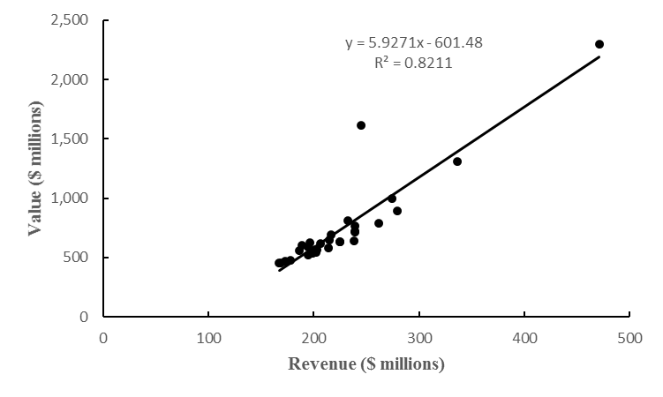
Scatter Diagram Excluding the New York Yankees Observation
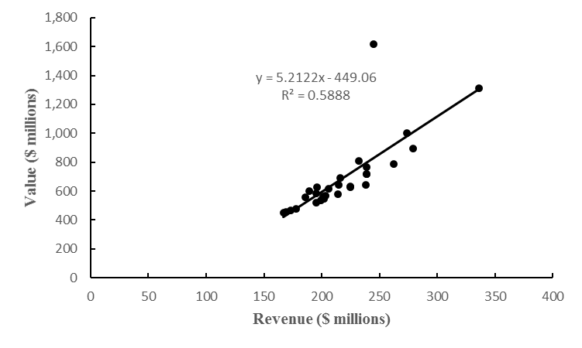

Supplementary Exercises
55. Does a high value of r² imply that two variables are causally related? Explain. LO 4
Solution:
No. Regression or correlation analysis can never prove that two variables are causally related.
56. In your own words, explain the difference between an interval estimate of the mean value of y for a given x and an interval estimate for an individual value of y for a given x. LO 8, 9
Solutions:
The estimate of a mean value is an estimate of the average of all y values associated with the same x. The estimate of an individual y value is an estimate of only one of the y values associated with a particular x.
57. What is the purpose of testing whether β₁ = 0? If we reject β₁ = 0, does it imply a good fit? LO 6
Solutions:
The purpose of testing whetheris to determine whether or not there is a significant relationship between x and y. However, rejectingdoes not necessarily imply a good fit. For example, if is rejected and r² is low, there is a statistically significant relationship between x and y but the fit is not very good.
58. Stock Market Performance. The Dow Jones Industrial Average (DJIA) and the Standard & Poor’s 500 (S&P 500) indexes are used as measures of overall movement in the stock market. The DJIA is based on the price movements of 30 large companies; the S&P 500 is an index composed of 500 stocks. Some say the S&P 500 is a better measure of stock market performance because it is broader based. The closing price for the DJIA and the S&P 500 for 15 weeks of a previous year follow (Barron’s website). LO 1, 2, 4, 7, 9
Date | DJIA | S&P
January 6 | 12,360 | 1,278
January 13 | 12,422 | 1,289
January 20 | 12,720 | 1,315
January 27 | 12,660 | 1,316
February 3 | 12,862 | 1,345
February 10 | 12,801 | 1,343
February 17 | 12,950 | 1,362
February 24 | 12,983 | 1,366
March 2 | 12,978 | 1,370
March 9 | 12,922 | 1,371
March 16 | 13,233 | 1,404
March 23 | 13,081 | 1,397
March 30 | 13,212 | 1,408
April 5 | 13,060 | 1,398
April 13 | 12,850 | 1,370
a. Develop a scatter diagram with DJIA as the independent variable.
b. Develop the estimated regression equation.
c. Test for a significant relationship. Use α = 0.05.
d. Did the estimated regression equation provide a good fit? Explain.
e. Suppose that the closing price for the DJIA is 13,500. Predict the closing price for the S&P 500.
f. Should we be concerned that the DJIA value of 13,500 used to predict the S&P 500 value in part (e) is beyond the range of the data used to develop the estimated regression equation?
Solutions:
a.

b. Using the file djiasp500 and Excel’s Descriptive Statistics Regression Tool, a portion of the Excel output is shown below:
Regression Statistics
Multiple R | 0.9740
R Square | 0.9486
Adjusted R Square | 0.9446
Standard Error | 9.6081
Observations | 15
ANOVA
 | df | SS | MS | F | Significance F
Regression | 1 | 22145.62926 | 22145.62926 | 239.8902 | 9.29184E-10
Residual | 13 | 1200.1041 | 92.3157
Total | 14 | 23345.73333
 | Coefficients | Standard Error | t Stat | p-Value
Intercept | –669.02124 | 130.7336 | –5.1174 | 0.0002
DJIA | 0.15727 | 0.0102 | 15.4884 | 9.29184E-10
= –669.02124 + 0.15727 DJIA
c. From the Excel output for both the F test and the t test on β₁ (coefficient of x), there is evidence of a significant relationship: p-value = 0 < α = 0.05; we reject; there is a significant relationship.
d. With R² = 94.86%, the estimated regression equation provided an excellent fit.
e.
f. The DJIA is not that far beyond the range of the data. With the excellent fit provided by the estimated regression equation, we should not be too concerned about using the estimated regression equation to predict the S&P500.
59. Home Size and Price. Is the number of square feet of living space a good predictor of a house’s selling price? The following data show the square footage and selling price for
15 houses in Winston Salem, North Carolina, in April 2015 (Zillow.com). LO 1, 2, 4, 6, 9
Size (1,000s sq. ft) | Selling Price ($1,000s)
1.26 | 117.5
3.02 | 299.9
1.99 | 139.0
0.91 | 45.6
1.87 | 129.9
2.63 | 274.9
2.60 | 259.9
2.27 | 177.0
2.30 | 175.0
2.08 | 189.9
1.12 | 95.0
1.38 | 82.1
1.80 | 169.0
1.57 | 96.5
1.45 | 114.9
a. Develop a scatter diagram with square feet of living space as the independent variable and selling price as the dependent variable. What does the scatter diagram indicate about the relationship between the size of a house and the selling price?
b. Develop the estimated regression equation that could be used to predict the selling price given the number of square feet of living space.
c. At the 0.05 level, is there a significant relationship between the two variables?
d. Use the estimated regression equation to predict the selling price of a 2,000 square foot house in Winston Salem, North Carolina.
e. Do you believe the estimated regression equation developed in part (b) will provide a good prediction of selling price of a particular house in Winston Salem, North Carolina? Explain.
f. Would you be comfortable using the estimated regression equation developed in part (b) to predict the selling price of a particular house in Seattle, Washington? Why or why not?
Solutions:
a.

The scatter diagram suggests that there is a linear relationship between size and selling price and that as size increases, selling price increases.
b. Using the file wshouses and Excel’s Descriptive Statistics Regression Tool, the Excel output appears below:
SUMMARY OUTPUT
Regression Statistics
Multiple R | 0.9474
R Square | 0.8975
Adjusted R Square | 0.8896
Standard Error | 24.6040
Observations | 15

ANOVA
 | df | SS | MS | F | Significance F
Regression | 1 | 68897.0802 | 68897.0802 | 113.8124 | 8.45157E-08
Residual | 13 | 7869.6358 | 605.3566
Total | 14 | 76766.7160

 | Coefficients | Standard Error | t Stat | P-value | Lower 95% | Upper 95% | Lower 95.0% | Upper 95%
Intercept | –59.0156 | 21.2877 | –2.7723 | 0.0158 | –105.0049 | –13.0262 | –105.0049 | –13.0262
Size (1,000’s  sq. ft.) | 115.0915 | 10.7882 | 10.6683 | 0.0000 | 91.7850 | 138.3979 | 91.7850 | 138.3979
The estimated regression equation is: = –59.0156 + 115.0915x
c. From the Excel output for both the F test and the t test on β₁ (coefficient of x), there is evidence of a significant relationship: p-value = 0 < α = 0.05.
d. = –59.016 + 115.091(square feet) = –59.0156 + 115.0915(2.0) = 171.167 or approximately $171,167.
e. The estimated regression equation should provide a good estimate because r² = 0.897.
f. This estimated equation might not work well for other cities. Housing markets are also driven by other factors that influence demand for housing, such as job market and quality-of-life factors. For example, because of the existence of high-tech jobs and its proximity to the ocean, the house prices in Seattle, Washington, might be very different from the house prices in Winston, Salem, North Carolina.
60. Online Education. One of the biggest changes in higher education in recent years has been the growth of online universities. The Online Education Database is an independent organization whose mission is to build a comprehensive list of the top accredited online colleges. The following table shows the retention rate (%) and the graduation rate (%) for 29 online colleges. LO 1, 4, 6, 11
Retention Rate (%) | Graduation Rate (%)
7 | 25
51 | 25
4 | 28
29 | 32
33 | 33
47 | 33
63 | 34
45 | 36
60 | 36
62 | 36
67 | 36
65 | 37
78 | 37
75 | 38
54 | 39
45 | 41
38 | 44
51 | 45
69 | 46
60 | 47
37 | 48
63 | 50
73 | 51
78 | 52
48 | 53
95 | 55
68 | 56
100 | 57
100 | 61
a. Develop a scatter diagram with retention rate as the independent variable. What does the scatter diagram indicate about the relationship between the two variables?
b. Develop the estimated regression equation.
c. Use a t test to determine whether there is a significant relationship. Use α = 0.05.
d. Did the estimated regression equation provide a good fit?
Solutions:
a.
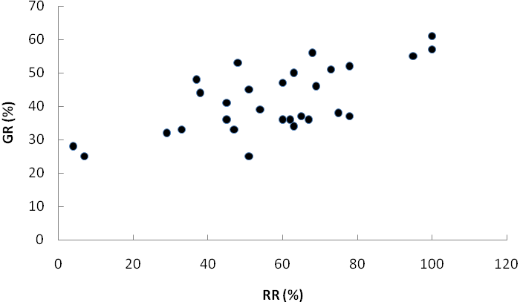
The scatter diagram indicates a positive linear relationship between the two variables. Online universities with higher retention rates tend to have higher graduation rates.
b. Using the file onlineedu and Excel’s Descriptive Statistics Regression Tool, the Excel output follows:
SUMMARY OUTPUT
Regression Statistics
Multiple R | 0.6702
R Square | 0.4492
Adjusted R Square | 0.4288
Standard Error | 7.4561
Observations | 29

ANOVA
 | df | SS | MS | F | Significance F
Regression | 1 | 1224.2860 | 1224.2860 | 22.0221 | 0.0001
Residual | 27 | 1501.0244 | 55.5935
Total | 28 | 2725.3103

 | Coefficients | Standard Error | t Stat | P-value | Lower 95% | Upper 95% | Lower 95.0% | Upper 95.0%
Intercept | 25.4229 | 3.7463 | 6.7862 | 0.0000 | 17.7362 | 33.1096 | 17.7362 | 33.1096
RR(%) | 0.2845 | 0.0606 | 4.6928 | 0.0001 | 0.1601 | 0.4089 | 0.1601 | 0.4089
= 25.4229 + 0.2845(RR %) = 25.4229 + 0.2845x
c. From the Excel output for both the F test and the t test on β₁ (coefficient of x), there is evidence of a significant relationship: p-value = 0.0001 < α = 0.05.
d. With r² = 0.4492, the estimated regression equation is able to explain 44.9% of the variability in the graduation rate based upon the linear relationship with the retention rate. It is not a great fit, but given the type of data, the fit is reasonably good.
61. Machine Maintenance. Jensen Tire & Auto is in the process of deciding whether to purchase a maintenance contract for its new computer wheel alignment and balancing machine. Managers feel that maintenance expense should be related to usage, and they collected the following information on weekly usage (hours) and annual maintenance expense (in hundreds of dollars). LO 1, 2, 7, 9
Weekly Usage (hours) | Annual Maintenance Expense
13 | 17.0
10 | 22.0
20 | 30.0
28 | 37.0
32 | 47.0
17 | 30.5
24 | 32.5
31 | 39.0
40 | 51.5
38 | 40.0
a. Develop the estimated regression equation that relates annual maintenance expense to weekly usage.
b. Test the significance of the relationship in part (a) at a 0.05 level of significance.
c. Jensen expects to use the new machine 30 hours per week. Develop a 95% prediction interval for the company’s annual maintenance expense.
d. If the maintenance contract costs $3,000 per year, would you recommend purchasing it? Why or why not?
Solutions:
Using the file jensen and Excel’s Descriptive Statistics Regression Tool, the Excel output is shown below:
Regression Statistics
Multiple R | 0.9253
R Square | 0.8562
Adjusted R Square | 0.8382
Standard Error | 4.2496
Observations | 10

ANOVA
 | df | SS | MS | F | Significance F
Regression | 1 | 860.0509486 | 860.0509 | 47.6238 | 0.0001
Residual | 8 | 144.4740514 | 18.0593
Total | 9 | 1004.525
 | Coefficients | Standard Error | t Stat | p-Value
Intercept | 10.5280 | 3.7449 | 2.8113 | 0.0228
Weekly Usage | 0.9534 | 0.1382 | 6.9010 | 0.0001
a. = 10.528 + 0.9534x
b. From the Excel output for both the F test and the t test on β₁ (coefficient of x), there is evidence of a significant relationship: p-value = 0.0001 < α = 0.05, we reject H₀: β₁ = 0.
c.
s² = MSE = SSE/(n – 2) = 144.474/8 = 18.059
df = n – 2 = 8 t_{a/2} = 2.306
= 10.528 + 0.9534(30) = 39.131
39.131 ± 2.306(4.504) = 39.131 ± 10.386
The 95% prediction interval is 28.74 to 49.52 or $2,874 to $4,952.
d. Yes, since the predicted expense for 30 hours is $3,913. Therefore, a $3,000 contract should save money.
62. Production Rate and Quality Control. In a manufacturing process the assembly line speed (feet per minute) was thought to affect the number of defective parts found during the inspection process. To test this theory, managers devised a situation in which the same batch of parts was inspected visually at a variety of line speeds. They collected the following data. LO 1, 4, 7, 8
Line Speed | Number of Defective  Parts Found
20 | 21
20 | 19
40 | 15
30 | 16
60 | 14
40 | 17
a. Develop the estimated regression equation that relates line speed to the number of defective parts found.
b. At a 0.05 level of significance, use the F test to determine whether line speed and number of defective parts found are related.
c. Did the estimated regression equation provide a good fit to the data?
d. Develop a 95% confidence interval to predict the mean number of defective parts for a line speed of 50 feet per minute.
Solutions:
a. The output follows.
Analysis of Variance
Source | DF | Adj SS | Adj MS | F-Value | P-Value
Regression | 1 | 25.130 | 25.130 | 11.33 | 0.028
Error | 4 | 8.870 | 2.217
Total | 5 | 34.000
Model Summary
S | R-sq | R-sq(adj)
1.48909 | 73.91% | 67.39%
Coefficients
Term | Coef | SE Coef | T-Value | P-Value | VIF
Constant | 22.17 | 1.65 | 13.42 | 0.000
Speed | –0.1478 | 0.0439 | –3.37 | 0.028 | 1.00
Regression Equation
Defects = 22.17 – 0.1478 Speed
Variable | Setting
Speed | 50

Fit | SE Fit | 95% CI | 95% PI
14.7826 | 0.896327 | (12.2940, 17.2712) | (9.95703, 19.6082)
b. Because the p-value corresponding to F = 11.33 = 0.028 < α = 0.05, the relationship is significant.
c. = 0.739; a good fit. The least squares line explained 73.9% of the variability in the number of defects.
d. Using the output in part a, the 95% confidence interval is 12.294 to 17.2712.
63. Absenteeism and Location. A sociologist was hired by a large city hospital to investigate the relationship between the number of unauthorized days that employees are absent per year and the distance (miles) between home and work for the employees. A sample of
10 employees was chosen, and the following data were collected. LO 1, 4, 7, 8
Distance to Work (miles) | Number of Days Absent
1 | 8
3 | 5
4 | 8
6 | 7
8 | 6
10 | 3
12 | 5
14 | 2
14 | 4
18 | 2
a. Develop a scatter diagram for these data. Does a linear relationship appear reasonable? Explain.
b. Develop the least squares estimated regression equation.
c. Based on the F test, is there a significant relationship between the two variables?
Use α = 0.05.
d. Did the estimated regression equation provide a good fit? Explain.
e. Use the estimated regression equation developed in part (b) to develop a 95% confidence interval for the expected number of days absent for employees living five miles from the company.
Solutions:
a. 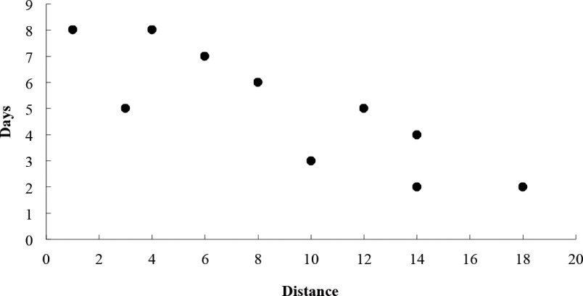
There appears to be a negative linear relationship between distance to work and number of days absent.
b. The output follows.
Analysis of Variance
Source | DF | Adj SS | Adj MS | F-Value | P-Value
Regression | 1 | 32.699 | 32.699 | 19.67 | 0.002
Error | 8 | 13.301 | 1.663
Total | 9 | 46.000
Model Summary
S | R-sq | R-sq(adj)
1.28941 | 71.09% | 67.47%
Coefficients
Term | Coef | SE Coef | T-Value | P-Value | VIF
Constant | 8.098 | 0.809 | 10.01 | 0.000
Distance | –0.3442 | 0.0776 | –4.43 | 0.002 | 1.00
Regression Equation
Days = 8.098 – 0.3442 Distance
Variable | Setting
Distance | 5

Fit | SE Fit | 95% CI | 95% PI
6.37681 | 0.512485 | (5.19502, 7.55860) | (3.17717, 9.57646)
c. Since the p-value corresponding to F = 19.67 is 0.002 < α = 0.05. We reject H₀ : β₁ = 0.
There is a significant relationship between the number of days absent and the distance to work.
d. r² = 0.711. The estimated regression equation explained 71.1% of the variability in y; this is a reasonably good fit.
e. The 95% confidence interval is 5.19502 to 7.5586 or approximately 5.2 to 7.6 days.
64. Bus Maintenance. The regional transit authority for a major metropolitan area wants to determine whether there is any relationship between the age of a bus and the annual maintenance cost. A sample of 10 buses resulted in the following data. LO 1, 4, 7, 9.
Age of Bus (years) | Maintenance Cost ($)
1 | 350
2 | 370
2 | 480
2 | 520
2 | 590
3 | 550
4 | 750
4 | 800
5 | 790
5 | 950
a. Develop the least squares estimated regression equation.
b. Use the F test to determine whether the two variables are significantly related with
α = 0.05.
c. Did the least squares line provide a good fit to the observed data? Explain.
d. Develop a 95% prediction interval for the maintenance cost for a specific bus that is four years old.
Solutions:
a. Using the file agecost and Excel’s Descriptive Statistics Regression Tool, the Excel output is shown below:
Regression Statistics
Multiple R | 0.9341
R Square | 0.8725
Adjusted R Square | 0.8566
Standard Error | 75.4983
Observations | 10
ANOVA
 | df | SS | MS | F | Significance F
Regression | 1 | 312050 | 312,050 | 54.7456 | 7.62662E-05
Residual | 8 | 45600 | 5,700
Total | 9 | 357650
 | Coefficients | Standard Error | t Stat | p-Value
Intercept | 220 | 58.4808 | 3.7619 | 0.0055
Age | 131.6667 | 17.7951 | 7.3990 | 7.63E-05
= 220 + 131.6667 Age
b. From the Excel output for both the F test and the t test on β₁ (coefficient of x), there is evidence of a significant relationship: p-value = 0.0001 < α = 0.05, we reject H₀: β₁ = 0.
c. r² = 0.873. The least squares line provided a very good fit.
d.
s² = MSE = SSE/(n – 2) = 45,600/8 = 5,700
df = n – 2 = 8 t_{a/2} = 2.306
= 220 + 131.667(4) = 746.667
746.667 ± 2.306(81.158) = 746.67 ± 187.15
The 95% prediction interval is 559.52 to 933.82 or $559.52 to $933.82
65. Studying and Grades. A marketing professor at Givens College is interested in the relationship between hours spent studying and total points earned in a course. Data collected on 10 students who took the course last quarter follow. LO 1, 2, 7, 9
Hours Spent Studying | Total  Points Earned
45 | 40
30 | 35
90 | 75
60 | 65
105 | 90
65 | 50
90 | 90
80 | 80
55 | 45
75 | 65
a. Develop an estimated regression equation showing how total points earned is related to hours spent studying.
b. Test the significance of the model with α = 0.05.
c. Predict the total points earned by Mark Sweeney. He spent 95 hours studying.
d. Develop a 95% prediction interval for the total points earned by Mark Sweeney.
Solutions:
a. Using the file hourspts and Excel’s Descriptive Statistics Regression Tool, the Excel output follows:
SUMMARY OUTPUT
Regression Statistics
Multiple R | 0.9369
R Square | 0.8777
Adjusted R Square | 0.8624
Standard Error | 7.5231
Observations | 10

ANOVA
 | df | SS | MS | F | Significance F
Regression | 1 | 3249.7208 | 3249.7208 | 57.4182 | 0.0001
Residual | 8 | 452.7792 | 56.5974
Total | 9 | 3702.5000

 | Coefficients | Standard Error | t Stat | P-value | Lower 95% | Upper 95% | Lower 95.0% | Upper 95%
Intercept | 5.8470 | 7.9717 | 0.7335 | 0.4842 | –12.5358 | 24.2299 | –12.5358 | 24.2299
Hours | 0.8295 | 0.1095 | 7.5775 | 0.0001 | 0.5771 | 1.0820 | 0.5771 | 1.0820
b. = 5.847 + 0.8295(Hours) = 5.847 + 0.8295x
From the Excel output for both the F test and the t test on β₁ (coefficient of x), there is evidence of a significant relationship: p-value = 0.0001 < α = 0.05, we reject H₀: β₁ = 0.
Total points earned are related to the hours spent studying.
c. Points = 5.8470 + 0.8295 Hours = 5.8470 + 0.8295 (95) = 84.65 points
d.
s² = MSE = SSE/(n – 2) = 452.779/8 = 56.597
df = n – 2 = 8 t_{a/2} = 2.306
= 5.847 + 0.8295(95) = 84.653
84.653 ± 2.306(8.37) = 84.653 ± 19.3
The 95% prediction interval is 65.353 to 103.954.
66. Market Beta. Market betas for individual stocks are determined by simple linear regression. For each stock, the dependent variable is its quarterly percentage return (capital appreciation plus dividends) minus the percentage return that could be obtained from a risk-free investment (the Treasury Bill rate is used as the risk-free rate). The independent variable is the quarterly percentage return (capital appreciation plus dividends) for the stock market (S&P 500) minus the percentage return from a risk-free investment. An estimated regression equation is developed with quarterly data; the market beta for the stock is the slope of the estimated regression equation (b₁). The value of the market beta is often interpreted as a measure of the risk associated with the stock. Market betas greater than one indicate that the stock is more volatile than the market average; market betas less than one indicate that the stock is less volatile than the market average. Suppose that the following figures are the differences between the percentage return and the risk-free return for 10 quarters for the S&P 500 and Horizon Technology. LO 1, 3, 4, 6
S&P 500 | Horizon
1.2 | –0.7
–2.5 | –2.0
–3.0 | –5.5
2.0 | 4.7
5.0 | 1.8
1.2 | 4.1
3.0 | 2.6
–1.0 | 2.0
0.5 | –1.3
2.5 | 5.5
a. Develop an estimated regression equation that can be used to predict the market beta for Horizon Technology. What is Horizon Technology’s market beta?
b. Use the t test to assess whether there is a significant relationship at the 0.05 level of significance.
c. Did the estimated regression equation provide a good fit? Explain.
Solutions:
a. The output follows.
Analysis of Variance
Source | DF | Adj SS | Adj MS | F-Value | P-Value
Regression | 1 | 50.26 | 50.255 | 7.08 | 0.029
Error | 8 | 56.78 | 7.098
Total | 9 | 107.04
Model Summary
S | R-sq | R-sq(adj)
2.66413 | 46.95% | 40.32%
Coefficients
Term | Coef | SE Coef | T-Value | P-Value | VIF
Constant | 0.275 | 0.900 | 0.31 | 0.768
S&P | 0.950 | 0.357 | 2.66 | 0.029 | 1.00
Regression Equation
Horizon = 0.275 + 0.950 S&P 500
The market beta for Horizon is b₁ = 0.95
b. Because the t statistic of 2.66 has a p-value = 0.029 is less than α = 0.05, the relationship is significant.
c. r² = 0.470. The least squares line does not provide an especially good fit.
67. Income and Percent Audited. The Transactional Records Access Clearinghouse at Syracuse University reported data showing the odds of an Internal Revenue Service audit. The following table shows the average adjusted gross income reported and the percent of the returns that were audited for 20 selected IRS districts. LO 1, 4, 6, 8
District | Adjusted  Gross Income ($) | Percent  Audited
Los Angeles | 36,664 | 1.3
Sacramento | 38,845 | 1.1
Atlanta | 34,886 | 1.1
Boise | 32,512 | 1.1
Dallas | 34,531 | 1.0
Providence | 35,995 | 1.0
San Jose | 37,799 | 0.9
Cheyenne | 33,876 | 0.9
Fargo | 30,513 | 0.9
New Orleans | 30,174 | 0.9
Oklahoma City | 30,060 | 0.8
Houston | 37,153 | 0.8
Portland | 34,918 | 0.7
Phoenix | 33,291 | 0.7
Augusta | 31,504 | 0.7
Albuquerque | 29,199 | 0.6
Greensboro | 33,072 | 0.6
Columbia | 30,859 | 0.5
Nashville | 32,566 | 0.5
Buffalo | 34,296 | 0.5
a. Develop the estimated regression equation that could be used to predict the percent audited given the average adjusted gross income reported.
b. At the 0.05 level of significance, use the t test to determine whether the adjusted gross income and the percent audited are related.
c. Did the estimated regression equation provide a good fit? Explain.
d. Use the estimated regression equation developed in part (a) to calculate a 95% confidence interval for the expected percent audited for districts with an average adjusted gross income of $35,000.
Solutions:
a. The output follows.
Analysis of Variance
Source | DF | Adj SS | Adj MS | F-Value | P-Value
Regression | 1 | 0.2175 | 0.21749 | 4.99 | 0.038
Error | 18 | 0.7845 | 0.04358
Total | 19 | 1.0020
Model Summary
S | R-sq | R-sq(adj)
0.208768 | 21.71% | 17.36%
Coefficients
Term | Coef | SE Coef | T-Value | P-Value | VIF
Constant | –0.471 | 0.584 | –0.81 | 0.431
Adjusted_Gross Income | 0.000039 | 0.000017 | 2.23 | 0.038 | 1.00
Regression Equation
Percent_Audited = –0.471 + 0.000039 Adjusted_Gross Income
Variable | Setting
Adjusted_Gross Income | 35,000

Fit | SE Fit | 95% CI | 95% PI
0.882770 | 0.0523186 | (0.772853, 0.992687) | (0.430602, 1.33494)
b. Because the t statistic of 2.23 has a p-value = 0.038 is less than α = 0.05, the relationship is significant.
c. r² = 0.217. The least squares line does not provide a good fit.
d. The 95% confidence interval is 0.772853 to 0.992687.
68. Used Car Mileage and Price. The Toyota Camry is one of the best-selling cars in North America. The cost of a previously owned Camry depends upon many factors, including the model year, mileage, and condition. To investigate the relationship between the car’s mileage and the sales price for a 2007 model year Camry, the following data show the mileage and sale price for 19 sales (PriceHub website). LO 1, 2, 3, 4, 6
Miles (1,000s) | Price ($1,000s)
22 | 16.2
29 | 16.0
36 | 13.8
47 | 11.5
63 | 12.5
77 | 12.9
73 | 11.2
87 | 13.0
92 | 11.8
101 | 10.8
110 | 8.3
28 | 12.5
59 | 11.1
68 | 15.0
68 | 12.2
91 | 13.0
42 | 15.6
65 | 12.7
110 | 8.3
a. Develop a scatter diagram with the car mileage on the horizontal axis and the price on the vertical axis.
b. What does the scatter diagram developed in part (a) indicate about the relationship between the two variables?
c. Develop the estimated regression equation that could be used to predict the price ($1,000s) given the miles (1,000s).
d. Test for a significant relationship at the 0.05 level of significance.
e. Did the estimated regression equation provide a good fit? Explain.
f. Provide an interpretation for the slope of the estimated regression equation.
g. Suppose that you are considering purchasing a previously owned 2007 Camry that has been driven 60,000 miles. Using the estimated regression equation developed in part (c), predict the price for this car. Is this the price you would offer the seller?
Solutions:
a.

b. There appears to be a negative relationship between the two variables that can be approximated by a straight line. An argument could also be made that the relationship is perhaps curvilinear because at some point a car has so many miles that its value becomes very small.
c. Using the file camry and Excel’s Descriptive Statistics Regression Tool, the Excel output is shown below.
Regression Statistics
Multiple R | 0.7339
R Square | 0.5387
Adjusted R Square | 0.5115
Standard Error | 1.5414
Observations | 19
ANOVA
 | df | SS | MS | F | Significance F
Regression | 1 | 47.1580 | 47.1580 | 19.8490 | 0.0003
Residual | 17 | 40.3893 | 2.3758
Total | 18 | 87.5474
 | Coefficients | Standard Error | t Stat | P-value
Intercept | 16.4698 | 0.9488 | 17.3592 | 2.98677E-12
Miles (1,000s) | –0.0588 | 0.0132 | –4.4552 | 0.0003
= 16.4698 – 0.0588 Miles (1,000s)
d. From the Excel output for both the F test and the t test on β₁ (coefficient of x), there is evidence of a significant relationship: p-value = 0.0003 < α = 0.05.
e. = 0.5387; a reasonably good fit considering that the condition of the car is also an important factor in what the price is.
f. The slope of the estimated regression equation is –0.0588. Thus, a one-unit increase in the value of x coincides with a decrease in the value of y equal to 0.0588. Because the data were recorded in thousands, every additional 1,000 miles on the car’s odometer will result in a $58.80 decrease in the predicted price.
g. The predicted price for a 2007 Camry with 60,000 miles is = 16.4698 – 0.0588(60) = 12.94 or approximately $13,000. Because of other factors, such as condition and whether the seller is a private party or a dealer, this is probably not the price you would offer for the car. But, it should be a good starting point in figuring out what to offer the seller.
69. Used Farm Equipment Prices. The following scatter chart shows the relationship between the price of a used tractor in dollars and the age of the tractor in years for 72 used tractors. LO 2, 3, 4
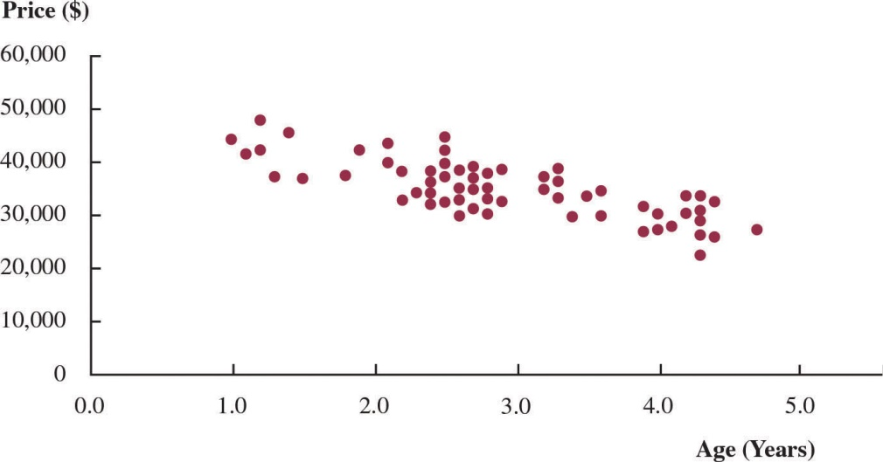
The regression output for these data is as follows:
Analysis of Variance
Source | DF | Adj SS | Adj MS | F-Value | p-Value
Regression | 1 | 1069527379.3 | 1069527379.3 | 100.06 | 0.00
Error | 70 | 748184308.9 | 10688347.3
Total | 71 | 1817711688.2

Model Summary
S | R-sq | R-sq(adj)
3,269.30 | 58.84% | 58.25%

Coefficients
Term | Coef | SE Coef | t Value | p-Value
Constant | 47315.67 | 1302.17 | 36.34 | 0.000
Age | –4251.89 | 425.05 | –10.00 | 0.000
Regression Equation
Price = 47315.67 – 4251.89 Age
a. Interpret the constant term.
b. Interpret the slope (coefficient of Age).
c. Does this regression equation provide a good fit to the data? Explain.
d. Using the regression equation, predict the price of a tractor that is 4.2 years old.
Solutions:
a. Since the intercept term is at age 0, it is an estimate of a new tractor. Hence, the price of a new tractor is estimated to be $47,315.67.
b. The estimate of the slope is –$4,251.89 so that the price of a used tractor drops by $4,251.89 per year.
c. The R² = 58.84% so that 58.74% of the variation in price is explained by the regression equation. This is not a good fit, but reasonable. There are clusters of data between ages two and three and just over age four. These patterns may make it difficult to get a better fit unless it is possible to identify an additional variable that accounts for these clusters.
d. Predicted Price = 47,315.67 – 4,251.89 (4.2) = $29,457.73
70. Used Farm Equipment Prices (Revisited). Refer to problem 69 concerning the impact of age of a used tractor and its selling price. LO 7, 10
a. At the 0.05 level of significance, use the F test to determine whether a significant statistical relationship exists between price and age of a tractor.
b. Analyze the following residual plot for the regression model to assess whether the linear regression assumptions about the error terms are valid.
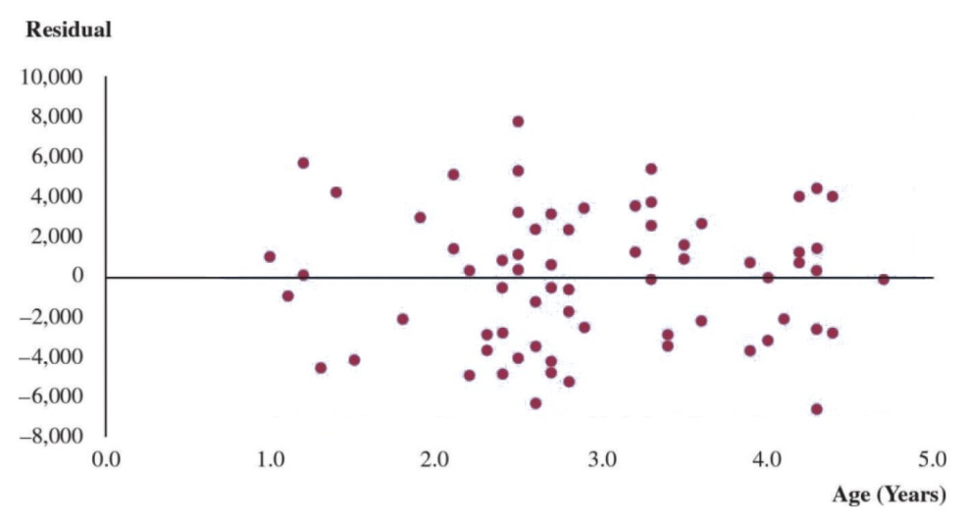
Solutions:
a. Yes there is a statistically significant relationship. The F statistic is 100.06 with a
p-value of 0.
b. The residual plot below shows that the residuals appear random and the variance seems relatively constant. The error assumptions seem to hold reasonably well.
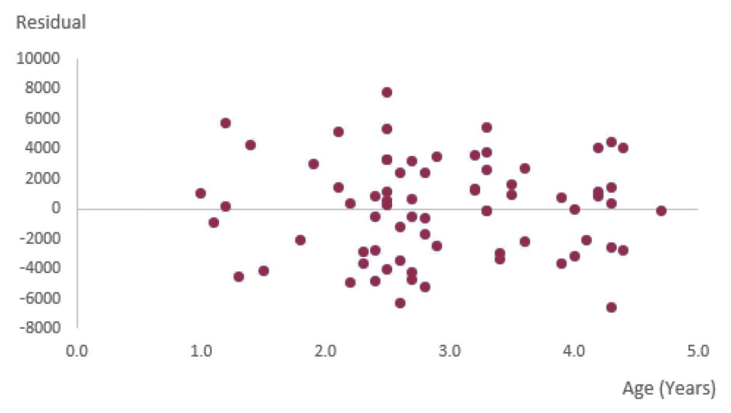
71. Sales and Banner Ads. An internet-based apparel company, Jimmy-C, wishes to study the effectiveness of its banner ads. The marketing team has sales (in millions of dollars) and the amount spent on banner ads for a given week (in millions of dollars) for 200 weeks. These data appear in the scatter plot below. LO 2, 3, 4
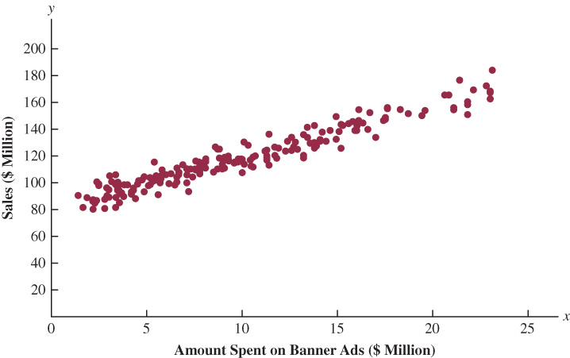
The regression output for these data is as follows:
Analysis of Variance
Source | DF | Adj SS | Adj MS | F-Value | p-Value
Regression | 1 | 94074.4 | 94074.4 | 2655.8 | 0.00
Error | 198 | 7013.5 | 35.4
Total | 199 | 101087.9

Model Summary
S | R-sq | R-sq(adj)
5.95 | 93.06% | 93.03%

Coefficients
Term | Coef | SE Coef | t Value | p-Value
Constant | 81.11 | 0.85 | 95.90 | 0.000
Amount Spent on Banner Ads | 3.87 | 0.08 | 51.53 | 0.000
Regression Equation
Sales = 81.11 + 3.87 Amount Spent on Banner Ads
a. Interpret the constant term.
b. Interpret the slope (coefficient of Amount Spent on Banner Ads).
c. Does this regression equation provide a good fit to the data? Explain.
d. Using the regression equation, predict the sales in a week when $15 million is spent on banner ads.
Solutions:
a. In a week with no money spent on banner ads, sales are estimated to be $81 million.
b. The slope is estimated to be 3.87 so that for every $1 million spent on banner ads, sales go up by $3.87 million.
c. The R² is 93.06% so that 93.06% of the variation in sales is explained by the regression equation. This is a good fit.
d. The predicted sales in millions = 81.11 + 3.87(15) = $139.16 million.
72. Sales and Banner Ads (Revisited). Refer to problem 71 and Jimmy-C’s study of the effectiveness of banner ads. LO 7, 10
a. At the 0.05 level of significance, use the F test to determine whether a significant statistical relationship exists between banner ad spend and sales.
b. Analyze the following residual plot for the regression to assess whether the linear regression assumptions about the error terms are valid.
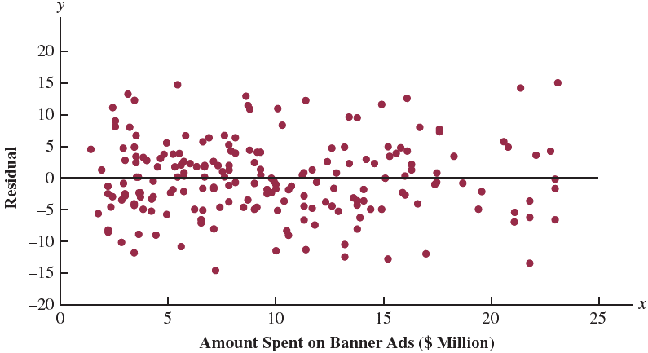
Solutions:
a. Yes there is a statistically significant relationship. The F statistic is 2,655.8 with a
p-value of 0.
b. The residual plot shows that the residuals appear random and the variance seems relatively constant. The error assumptions seem to hold well.
73. On Base Percentage and Runs Scored. As shown in the film Moneyball, the Oakland A’s major league baseball team used analytics to their advantage in player selection. By using techniques such as regression analysis, they were able to find new metrics that are important to success. One of those metrics the A’s found to be helpful is “on-base percentage” (OBP). OBP is the number of times a player reaches a base divided by the number of plate appearances. The file OBP contains OBP and total runs scored over the season for every major league baseball team over a 12-year period. LO 1, 2, 3, 4
a. Construct a scatter plot. Does there appear to be a linear relationship between runs scored and OBP?
b. Using computer software, develop a regression equation with runs scored as the dependent variable and OBP as the independent variable.
c. Interpret the slope OBP. As OBP increases by 0.01, how is the number of runs scored predicted to change?
d. Does this regression equation provide a good fit to the data? Explain.
e. Using the regression equation, predict the runs scored in a season in which the OBP is 33% (0.33).
Solutions:
a. A scatter plot of runs scored in a year versus on base percentage that year is shown below. There does appear to be a linear relationship.
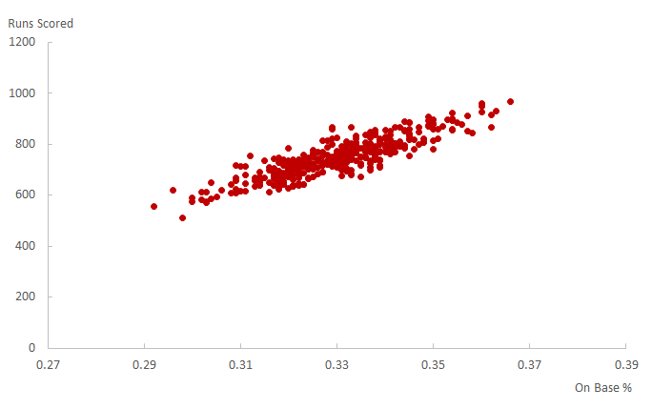
b. RS = –993.55 + 5274.10 OBP
Output from Excel’s regression tool follows:
SUMMARY OUTPUT
Regression Statistics
Multiple R | 0.877979
R Square | 0.770848
Adjusted R Square | 0.770208
Standard Error | 37.83829
Observations | 360

ANOVA
 | df | SS | MS | F | Significance F
Regression | 1 | 1724213.18 | 1724213.18 | 1204.28 | 0.00
Residual | 358 | 512561.44 | 1431.74
Total | 359 | 2236774.62

 | Coefficients | Standard Error | t Stat | P-value | Lower 95% | Upper 95%
Intercept | –993.55 | 50.23 | –19.78 | 0.00 | –1092.33 | –894.77
OBP | 5274.10 | 151.98 | 34.70 | 0.00 | 4975.22 | 5572.99
c. The estimate of the slope is 5,274.10 meaning for every increase of 0.01 in OBP, runs scored go up by 52.74.
d. The R² for this equation is 77.02%, meaning that 77.02 percent of the variation in runs scored is explained by OBP. This is a good fit.
e. Runs scored = –993.55 + 5,274.10 (0.33) = 746.903 or about 747 runs.
74. On Base Percentage and Runs Scored (Revisited). Refer to problem 73 and the baseball data on runs scored in a season and on base percentage. Develop a residual plot with residuals on the vertical axis and OBS on the horizontal axis. Based on this residual plot, do the assumptions about the error terms for this regression analysis seem reasonable? LO 10
Solutions:
The residual plot follows. The residual plot shows that the residuals appear random and the variance seems relatively constant. The error assumptions seem to hold.
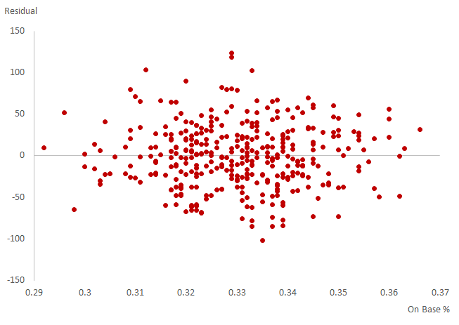

Case Problem 1: Measuring Stock Market Risk
One measure of the risk or volatility of an individual stock is the standard deviation of the total return (capital appreciation plus dividends) over several periods of time. Although the standard deviation is easy to compute, it does not take into account the extent to which the price of a given stock varies as a function of a standard market index, such as the S&P 500. As a result, many financial analysts prefer to use another measure of risk referred to as beta.
Betas for individual stocks are determined by simple linear regression. The dependent variable is the total return for the stock and the independent variable is the total return for the stock market. For this case problem we will use the S&P 500 index as the measure of the total return for the stock market, and an estimated regression equation will be developed using monthly data. The beta for the stock is the slope of the estimated regression equation (b₁). The data contained in the file beta provides the total return (capital appreciation plus dividends) over 36 months for eight widely traded common stocks and the S&P 500.
The value of beta for the stock market will always be one; thus, stocks that tend to rise and fall with the stock market will also have a beta close to one. Betas greater than one indicate that the stock is more volatile than the market, and betas less than one indicate that the stock is less volatile than the market. For instance, if a stock has a beta of 1.4, it is 40% more volatile than the market, and if a stock has a beta of 0.4, it is 60% less volatile than the market. LO 1, 3, 4
Managerial Report
You have been assigned to analyze the risk characteristics of these stocks. Prepare a report that includes but is not limited to the following items.
a. Compute descriptive statistics for each stock and the S&P 500. Comment on your results. Which stocks are the most volatile?
b. Compute the value of beta for each stock. Which of these stocks would you expect to perform best in an up market? Which would you expect to hold their value best in a down market?
c. Comment on how much of the return for the individual stocks is explained by the market.
Solutions:
a. Selected descriptive statistics follow:
Variable | N | Mean | StDev | Minimum | Median | Maximum
Microsoft | 36 | 0.00503 | 0.04537 | –0.08201 | 0.00400 | 0.08883
Exxon Mobil | 36 | 0.01664 | 0.05534 | –0.11646 | 0.01279 | 0.23217
Caterpillar | 36 | 0.03010 | 0.06860 | –0.10060 | 0.04080 | 0.21850
Johnson & Johnson | 36 | 0.00530 | 0.03487 | –0.05917 | -0.00148 | 0.10334
McDonald’s | 36 | 0.02450 | 0.06810 | –0.11440 | 0.03700 | 0.18260
Sandisk | 36 | 0.06930 | 0.19540 | –0.28330 | 0.07410 | 0.50170
Qualcomm | 36 | 0.02840 | 0.08620 | –0.12170 | 0.03870 | 0.21060
Procter & Gamble | 36 | 0.01059 | 0.03707 | –0.05365 | 0.01333 | 0.08783
S&P 500 | 36 | 0.01010 | 0.02633 | -0.03429 | 0.01034 | 0.08104
From the descriptive statistics we see that six of the companies had a higher mean monthly return than the market (as measured by the S&P 500): Exxon Mobil, Caterpillar, McDonald’s, Sandisk, Qualcomm, and Procter & Gamble. Microsoft and Johnson & Johnson had lower mean monthly returns.
Using the standard deviation as a measure of volatility, Sandisk was the most volatile stock with a standard deviation of 0.1954. The stocks of Johnson & Johnson and P & G exhibit less volatility than the other individual stocks. But all of the individual stocks are more volatile than the market as a whole. The diversification embodied in the S&P 500 reduces its volatility.
b. The estimated regression equation relating each of the individual stocks to the S&P 500 is shown below. The value of r² for each equation is also shown.
Microsoft = 0.00040 + 0.458 S&P 500 r² = 0.071
Exxon Mobil = 0.00926 + 0.731 S&P 500 r² = 0.121
Caterpillar = 0.015000 + 1.49 S&P 500 r² = 0.329
Johnson & Johnson = 0.00521 + 0.009 S&P 500 r² = 0.000
McDonald’s = 0.00930 + 1.500 S&P 500 r² = 0.338
Sandisk = 0.04300 + 2.600 S&P 500 r² = 0.123
Qualcomm = 0.01410 + 1.410 S&P 500 r² = 0.187
Procter & Gamble = 0.00548 + 0.507 S&P 500 r² = 0.129
The betas (slope of estimated regression equation) for the individual stocks can be obtained from the regression output.
Company | Beta
Microsoft | 0.458
Exxon Mobil | 0.731
Caterpillar | 1.490
Johnson & Johnson | 0.009
McDonald’s | 1.500
Scandisk | 2.600
Qualcomm | 1.410
The beta for the market as a whole is 1. So, any stock with a beta greater than one will move up faster than the market when the market goes up. Any stock with a beta less than one will not go down as fast as the market in periods where the market declines.
We would expect Scandisk, with a beta of 2.6, to benefit most from an up market. Johnson & Johnson, with a beta of 0.009, is least affected by the market. The effect of the market going down cannot be expected to exert much downward pressure on shares of Johnson & Johnson.
c. The r² values seem to indicate that from 0% to 33.8% of the variability of the returns in these individual stocks is explained by the return for the market.

Case Problem 2: U.S. Department of Transportation
As part of a study on transportation safety, the U.S. Department of Transportation collected data on the number of fatal accidents per 1,000 licenses and the percentage of licensed drivers under the age of 21 in a sample of 42 cities. Data collected over a one-year period follow. These data are contained in the file safety. LO 1, 4, 7, 10, 11
Percent  Under 21 | Fatal Accidents  per 1,000 Licenses | Percent  Under 21 | Fatal Accidents  per 1,000 Licenses
13 | 2.962 | 17 | 4.100
12 | 0.708 | 8 | 2.190
8 | 0.885 | 16 | 3.623
12 | 1.652 | 15 | 2.623
11 | 2.091 | 9 | 0.835
17 | 2.627 | 8 | 0.820
18 | 3.830 | 14 | 2.890
8 | 0.368 | 8 | 1.267
13 | 1.142 | 15 | 3.224
8 | 0.645 | 10 | 1.014
9 | 1.028 | 10 | 0.493
16 | 2.801 | 14 | 1.443
12 | 1.405 | 18 | 3.614
9 | 1.433 | 10 | 1.926
10 | 0.039 | 14 | 1.643
9 | 0.338 | 16 | 2.943
11 | 1.849 | 12 | 1.913
12 | 2.246 | 15 | 2.814
14 | 2.855 | 13 | 2.634
14 | 2.352 | 9 | 0.926
11 | 1.294 | 17 | 3.256
Managerial Report
1. Develop numerical and graphical summaries of the data.
2. Use regression analysis to investigate the relationship between the number of fatal accidents and the percentage of drivers under the age of 21. Discuss your findings.
3. What conclusion and recommendations can you derive from your analysis?
Solutions:
1. The descriptive statistics and graphical summaries are shown below:
Percent  Under 21 |  | Fatal Accidents  per 1,000
Mean | 12.2619 | Mean | 1.9224
Standard Error | 0.4832 | Standard Error | 0.1653
Median | 12 | Median | 1.881
Mode | 8 | Mode | #N/A
Standard Deviation | 3.1317 | Standard Deviation | 1.0710
Sample Variance | 9.8078 | Sample Variance | 1.1470
Kurtosis | –1.13711 | Kurtosis | –0.9749
Skewness | 0.2104 | Skewness | 0.1932
Range | 10 | Range | 4.061
Minimum | 8 | Minimum | 0.039
Maximum | 18 | Maximum | 4.1
Sum | 515 | Sum | 80.741
Count | 42 | Count | 42
The following scatter diagram suggests a linear relationship between these two variables:

2. A portion of the Excel Regression tool output is shown below:
Regression Statistics
Multiple R | 0.8394
R Square | 0.7046
Adjusted R Square | 0.6972
Standard Error | 0.5894
Observations | 42
ANOVA
 | df | SS | MS | F | Significance F
Regression | 1 | 33.1344 | 33.1344 | 95.3965 | 3.79357E-12
Residual | 40 | 13.8934 | 0.3473
Total | 41 | 47.0278
 | Coefficients | Standard Error | t Stat | p-Value
Intercept | –1.5974 | 0.3717 | –4.2979 | 0.0001
Percent Under 21 | 0.2871 | 0.0294 | 9.7671 | 3.7936E-12
3. There is a significant relationship between the two variables. It appears that the number of fatal accidents per 1,000 licenses is linearly related to the percentage of licensed drivers under the age of 21; that is, the higher the percentage of drivers under 21, the larger the number.

Case Problem 3: Selecting a Point-and-Shoot Digital Camera
Consumer Reports tested 166 different point-and-shoot digital cameras. Based upon factors such as the number of megapixels, weight (oz), image quality, and ease of use, they developed an overall score for each camera tested. The overall score ranges from 0 to 100, with higher scores indicating better overall test results. Selecting a camera with many options can be a difficult process, and price is certainly a key issue for most consumers. By spending more, will a consumer really get a superior camera? And, do cameras that have more megapixels, a factor often considered to be a good measure of picture quality, cost more than cameras with fewer megapixels? Table 14.15 shows the brand, average retail price ($), number of megapixels, weight (oz), and the overall score for 13 Canon and 15 Nikon subcompact cameras tested by Consumer Reports (Consumer Reports website). LO 1, 4, 5, 7, 10, 11
TABLE 14.15 Data for 28 Point-and-Shoot Digital Cameras
Camera | Brand | Price  ($) | Megapixels | Weight  (oz) | Score
1 | Canon | 330 | 10 | 7 | 66
2 | Canon | 200 | 12 | 5 | 66
3 | Canon | 300 | 12 | 7 | 65
4 | Canon | 200 | 10 | 6 | 62
5 | Canon | 180 | 12 | 5 | 62
6 | Canon | 200 | 12 | 7 | 61
7 | Canon | 200 | 14 | 5 | 60
8 | Canon | 130 | 10 | 7 | 60
9 | Canon | 130 | 12 | 5 | 59
10 | Canon | 110 | 16 | 5 | 55
11 | Canon | 90 | 14 | 5 | 52
12 | Canon | 100 | 10 | 6 | 51
13 | Canon | 90 | 12 | 7 | 46
14 | Nikon | 270 | 16 | 5 | 65
15 | Nikon | 300 | 16 | 7 | 63
16 | Nikon | 200 | 14 | 6 | 61
17 | Nikon | 400 | 14 | 7 | 59
18 | Nikon | 120 | 14 | 5 | 57
19 | Nikon | 170 | 16 | 6 | 56
20 | Nikon | 150 | 12 | 5 | 56
21 | Nikon | 230 | 14 | 6 | 55
22 | Nikon | 180 | 12 | 6 | 53
23 | Nikon | 130 | 12 | 6 | 53
24 | Nikon | 80 | 12 | 7 | 52
25 | Nikon | 80 | 14 | 7 | 50
26 | Nikon | 100 | 12 | 4 | 46
27 | Nikon | 110 | 12 | 5 | 45
28 | Nikon | 130 | 14 | 4 | 42
Managerial Report
1. Develop numerical summaries of the data.
2. Using overall score as the dependent variable, develop three scatter diagrams, one using price as the independent variable, one using the number of megapixels as the independent variable, and one using weight as the independent variable. Which of the three independent variables appears to be the best predictor of overall score?
3. Using simple linear regression, develop an estimated regression equation that could be used to predict the overall score given the price of the camera.
4. Analyze the data using only the observations for the Canon cameras. Discuss the appropriateness of using simple linear regression and make any recommendations regarding the prediction of overall score using just the price of the camera.
Solutions:
1. Descriptive statistics for the data set follow.
 | Price ($) | Megapixels | Weight (oz.) | Score
Mean | 175.36 | 12.86 | 5.82 | 56.36
Standard Error | 15.65 | 0.35 | 0.19 | 1.27
Median | 160 | 12 | 6 | 56.5
Mode | 200 | 12 | 5 | 66
Standard Deviation | 82.80 | 1.84 | 0.98 | 6.70
Sample Variance | 6,855.42 | 3.39 | 0.97 | 44.83
Kurtosis | 0.66 | –0.63 | –1.19 | –0.62
Skewness | 1.06 | 0.23 | -0.12 | –0.43
Range | 320 | 6 | 3 | 24
Minimum | 80 | 10 | 4 | 42
Maximum | 400 | 16 | 7 | 66
Sum | 4,910 | 360 | 163 | 1,578
Count | 28 | 28 | 28 | 28
The sample correlation coefficients for this data set follow.
 | Price ($) | Megapixels | Weight (oz.) | Score
Price ($) | 1
Megapixels | 0.1389 | 1
Weight (oz.) | 0.3488 | –0.1988 | 1
Score | 0.6832 | –0.0077 | 0.2857 | 1
With a sample correlation coefficient of 0.6832, price appears to be the best predictor of the overall score.
2. Scatter diagrams for the data are shown below.

There appears to be a positive relationship between the price of the camera and the overall score. But, observation 17, a Nikon camera with a price of $400, appears to be an observation that will have a significant impact when we fit a linear model to these data. It may be worth considering restricting the analysis to cameras that have a price of less than $400. Another possible explanation for what we observe here is that the underlying relationship may not be linear. In other words, the somewhat curvilinear trend in the data may be due to diminishing returns.

The number of megapixels does not appear to have much effect on the overall score. But note that as the number of megapixels increase from 10 to 14, the overall score appears to have a downward trend; that is the overall score is decreasing. This seems to be counterintuitive in that generally speaking, higher megapixel cameras are usually considered to have better picture quality. But, the overall score for the 16-megapixel cameras does increase somewhat.

There may be a modest increase in overall score for cameras that weigh more. Also note the large variability in the score for cameras with a weight of five ounces and cameras with a weight of ounces ounces. The pattern in the data may also be an indication that the effect of weight may also involve some curvilinear effect.
Conclusion: The variable that appears to be the best predictor of overall score is the price of the camera.
3. A portion of the Excel output follows:
Regression Statistics
Multiple R | 0.6832
R Square | 0.4668
Adjusted R Square | 0.4463
Standard Error | 4.9824
Observations | 28
ANOVA
 | df | SS | MS | F | Significance F
Regression | 1 | 565.0019 | 565.0019 | 22.7602 | 6.15507E-05
Residual | 26 | 645.4266 | 24.8241
Total | 27 | 1210.4286
 | Coefficients | Standard Error | t Stat | p-Value
Intercept | 46.6688 | 2.2384 | 20.8488 | 9.38682E-18
Price ($) | 0.0552 | 0.0116 | 4.7708 | 6.15507E-05
With a p-value = 0.000, price is a significant factor in predicting the overall score. The estimated regression equation explained 46.68% of the variability in the overall score.
4. Using only the data for the Canon cameras, the scatter diagram using the price of the camera as the independent variable follows.

There does appear to be a relationship between the price of the camera and the overall score. But the relationship appears to be curvilinear. However, using simple linear regression for these data we obtain the following output.
Regression Statistics
Multiple R | 0.8270
R Square | 0.6839
Adjusted R Square | 0.6552
Standard Error | 3.6185
Observations | 13
ANOVA
 | df | SS | MS | F | Significance F
Regression | 1 | 311.6605 | 311.6605 | 23.8021 | 0.0005
Residual | 11 | 144.0319 | 13.0938
Total | 12 | 455.6923
 | Coefficients | Standard Error | t Stat | p-Value
Intercept | 47.2880 | 2.5729 | 18.3793 | 1.32053E-09
Price ($) | 0.0665 | 0.0136 | 4.8787 | 0.0005
The estimated regression equation is significant and explains 68.39% of the variability in the overall score using the price of the camera. But the curvilinear relationship we observed in the scatter diagram is still a concern. The issue whether the underlying relationship may be better described by curvilinear model cannot be resolved using the methods introduced in this chapter.

Case Problem 4: Finding the Best Car Value
When trying to decide what car to buy, real value is not necessarily determined by how much you spend on the initial purchase. Instead, cars that are reliable and don’t cost much to own often represent the best values. But, no matter how reliable or inexpensive a car may cost to own, it must also perform well.
To measure value, Consumer Reports developed a statistic referred to as a value score. The value score is based upon five-year owner costs, overall road-test scores, and predicted reliability ratings. Five-year owner costs are based on the expenses incurred in the first five years of ownership, including depreciation, fuel, maintenance and repairs, and so on. Using a national average of 12,000 miles per year, an average cost per mile driven is used as the measure of five-year owner costs. Road-test scores are the results of more than 50 tests and evaluations and are based upon a 100-point scale, with higher scores indicating better performance, comfort, convenience, and fuel economy. The highest road-test score obtained in the tests conducted by Consumer Reports was a 99 for a Lexus LS 460L. Predicted-reliability ratings (1 = Poor, 2 = Fair, 3 = Good, 4 = Very Good, and 5 = Excellent) are based on data from Consumer Reports’ Annual Auto Survey.
A car with a value score of 1.0 is considered to be “average-value.” A car with a value score of 2.0 is considered to be twice as good a value as a car with a value score of 1.0; a car with a value score of 0.5 is considered half as good as average; and so on. The data for 20 family sedans, including the price ($) of each car tested, follow. LO 1, 4, 7
Car | Price ($) | Cost/Mile | Road-Test  Score | Predicted  Reliability | Value Score
Nissan Altima 2.5 S (4-cyl.) | 23,970 | 0.59 | 91 | 4 | 1.75
Kia Optima LX (2.4) | 21,885 | 0.58 | 81 | 4 | 1.73
Subaru Legacy 2.5i Premium | 23,830 | 0.59 | 83 | 4 | 1.73
Ford Fusion Hybrid | 32,360 | 0.63 | 84 | 5 | 1.70
Honda Accord LX-P (4-cyl.) | 23,730 | 0.56 | 80 | 4 | 1.62
Mazda6 i Sport (4-cyl.) | 22,035 | 0.58 | 73 | 4 | 1.60
Hyundai Sonata GLS (2.4) | 21,800 | 0.56 | 89 | 3 | 1.58
Ford Fusion SE (4-cyl.) | 23,625 | 0.57 | 76 | 4 | 1.55
Chevrolet Malibu LT (4-cyl.) | 24,115 | 0.57 | 74 | 3 | 1.48
Kia Optima SX (2.0T) | 29,050 | 0.72 | 84 | 4 | 1.43
Ford Fusion SEL (V6) | 28,400 | 0.67 | 80 | 4 | 1.42
Nissan Altima 3.5 SR (V6) | 30,335 | 0.69 | 93 | 4 | 1.42
Hyundai Sonata Limited (2.0T) | 28,090 | 0.66 | 89 | 3 | 1.39
Honda Accord EX-L (V6) | 28,695 | 0.67 | 90 | 3 | 1.36
Mazda6 s Grand Touring (V6) | 30,790 | 0.74 | 81 | 4 | 1.34
Ford Fusion SEL (V6, AWD) | 30,055 | 0.71 | 75 | 4 | 1.32
Subaru Legacy 3.6R Limited | 30,094 | 0.71 | 88 | 3 | 1.29
Chevrolet Malibu LTZ (V6) | 28,045 | 0.67 | 83 | 3 | 1.20
Chrysler 200 Limited (V6) | 27,825 | 0.70 | 52 | 5 | 1.20
Chevrolet Impala LT (3.6) | 28,995 | 0.67 | 63 | 3 | 1.05
Managerial Report
1. Develop numerical summaries of the data.
2. Use regression analysis to develop an estimated regression equation that could be used to predict the value score given the price of the car.
3. Use regression analysis to develop an estimated regression equation that could be used to predict the value score given the five-year owner costs (cost/mile).
4. Use regression analysis to develop an estimated regression equation that could be used to predict the value score given the road-test score.
5. Use regression analysis to develop an estimated regression equation that could be used to predict the value score given the predicted-reliability.
6. What conclusions can you derive from your analysis?
Solutions:
1. Descriptive statistics follow.
 | Price ($) | Cost/Mile | Road-Test Score | Predicted Reliability | Value Score
Mean | 26,886.20 | 0.642 | 80.45 | 3.75 | 1.46
Standard Error | 754.51 | 0.01 | 2.21 | 0.14 | 0.04
Median | 28,067.50 | 0.665 | 82 | 4 | 1.43
Mode | #N/A | 0.67 | 81 | 4 | 1.73
Standard Deviation | 3,374.28 | 0.06 | 9.90 | 0.64 | 0.20
Sample Variance | 11,385,793.54 | 0.00 | 98.05 | 0.41 | 0.04
Kurtosis | –1.41 | –1.58 | 2.58 | –0.44 | –0.64
Skewness | –0.23 | –0.04 | –1.41 | 0.25 | –0.18
Range | 10,560 | 0.18 | 41 | 2 | 0.7
Minimum | 21,800 | 0.56 | 52 | 3 | 1.05
Maximum | 32,360 | 0.74 | 93 | 5 | 1.75
Sum | 537,724 | 12.84 | 1,609 | 75 | 29.16
Count | 20 | 20 | 20 | 20 | 20
2. A portion of the Excel output follows.
Regression Statistics
Multiple R | 0.5725
R Square | 0.3277
Adjusted R Square | 0.2904
Standard Error | 0.1663
Observations | 20
ANOVA
 | df | SS | MS | F | Significance F
Regression | 1 | 0.2428 | 0.2428 | 8.7754 | 0.0083
Residual | 18 | 0.4980 | 0.0277
Total | 19 | 0.7407
 | Coefficients | Standard Error | t Stat | p-Value
Intercept | 2.3587 | 0.3063 | 7.7004 | 4.2026E-07
Price ($) | 0.0000 | 0.0000 | –2.9623 | 0.0083
3. A portion of the Excel output follows.
Regression Statistics
Multiple R | 0.7164
R Square | 0.5132
Adjusted R Square | 0.4861
Standard Error | 0.1415
Observations | 20
ANOVA
 | df | SS | MS | F | Significance F
Regression | 1 | 0.3801 | 0.3801 | 18.9741 | 0.0004
Residual | 18 | 0.3606 | 0.0200
Total | 19 | 0.7407
 | Coefficients | Standard Error | t Stat | P-value
Intercept | 2.9422 | 0.3422 | 8.5979 | 8.65063E-08
Cost/Mile | –2.3119 | 0.5307 | –4.3559 | 0.0004
4. A portion of the Excel output follows.
Regression Statistics
Multiple R | 0.4116
R Square | 0.1694
Adjusted R Square | 0.1232
Standard Error | 0.1849
Observations | 20
ANOVA
 | df | SS | MS | F | Significance F
Regression | 1 | 0.1255 | 0.1255 | 3.6704 | 0.0714
Residual | 18 | 0.6153 | 0.0342
Total | 19 | 0.7407
 | Coefficients | Standard Error | t Stat | p-Value
Intercept | 0.7978 | 0.3471 | 2.2986 | 0.0337
Road-Test Score | 0.0082 | 0.0043 | 1.9158 | 0.0714
5. A portion of the Excel output follows.
Regression Statistics
Multiple R | 0.3506
R Square | 0.1229
Adjusted R Square | 0.0742
Standard Error | 0.1900
Observations | 20
ANOVA
 | df | SS | MS | F | Significance F
Regression | 1 | 0.0910 | 0.0910 | 2.5225 | 0.1296
Residual | 18 | 0.6497 | 0.0361
Total | 19 | 0.7407
 | Coefficients | Standard Error | t Stat | p-Value
Intercept | 1.0515 | 0.2594 | 4.0535 | 0.0007
Predicted Reliability | 0.1084 | 0.0682 | 1.5882 | 0.1296
6. Although Consumer Reports did not include price as one of the components of value score, the regression output shown in part (2) shows that there is a significant statistical relationship between price ($) and value score (p-value = 0.0083). Reviewing the regression output in parts (3) to (5) indicates that cost/mile is the best single predictor of value score (R² = 0.5132). To further investigate the relationship among these variables we really need to use multiple regression analysis.

Case Problem 5: Buckeye Creek Amusement Park
Buckeye Creek Amusement Park is open from the beginning of May to the end of October. Buckeye Creek relies heavily on the sale of season passes. The sale of season passes brings in significant revenue prior to the park opening each season, and season pass holders contribute a substantial portion of the food, beverage, and novelty sales in the park. Greg Ross, director of marketing at Buckeye Creek, has been asked to develop a targeted marketing campaign to increase season pass sales.
Greg has data for last season that show the number of season pass holders for each zip code within 50 miles of Buckeye Creek. He has also obtained the total population of each zip code from the U.S. Census Bureau website. Greg thinks it may be possible to use regression analysis to predict the number of season pass holders in a zip code given the total population of a zip code. If this is possible, he could then conduct a direct mail campaign that would target zip codes that have fewer than the expected number of season pass holders. LO 1, 4, 6, 10
Managerial Report
1. Compute descriptive statistics and construct a scatter diagram for the data. Discuss your findings.
2. Using simple linear regression, develop an estimated regression equation that could be used to predict the number of season pass holders in a zip code given the total population of the zip code.
3. Test for a significant relationship at the 0.05 level of significance.
4. Did the estimated regression equation provide a good fit?
5. Use residual analysis to determine whether the assumed regression model is appropriate.
6. Discuss if/how the estimated regression equation should be used to guide the marketing campaign.
7. What other data might be useful to predict the number of season pass holders in a zip code?
Solutions:
1. Descriptive statistics for the dependent and independent variables and a scatter plot of these two variables follow. The mean population over the 151 zip codes is 15,738.2 and the mean number of season pass holders is 128.3. Over all zip codes, the maximum population is 62,303 and the minimum is 1,227. The maximum number of season pass holders is 657 and the minimum is 5.
Population |  |  | Season Pass Holders
Mean | 15,738.2 |  | Mean | 128.3
Standard Error | 1,028.6 |  | Standard Error | 11.8
Median | 12,675 |  | Median | 59
Mode | #N/A |  | Mode | 11
Standard Deviation | 12,640 |  | Standard Deviation | 145.4
Sample Variance | 159,758,062 |  | Sample Variance | 21,135
Kurtosis | 1.6 |  | Kurtosis | 1.5
Skewness | 1.3 |  | Skewness | 1.4
Range | 61,076 |  | Range | 652
Minimum | 1,227 |  | Minimum | 5
Maximum | 62,303 |  | Maximum | 657
Sum | 2,376,471 |  | Sum | 19,368
Count | 151 |  | Count | 151
Largest(1) | 62,303 |  | Largest(1) | 657
Smallest(1) | 1,227 |  | Smallest(1) | 5
Confidence Level(95.0%) | 2,032 |  | Confidence Level(95.0%) | 23.4
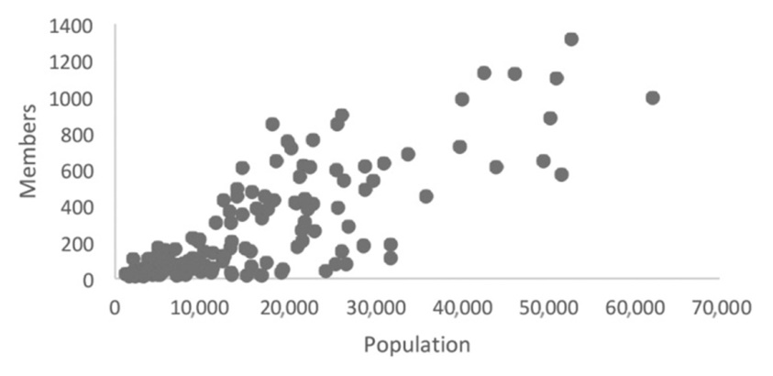
There appears to be a positive linear relationship between the population of a zip code and the number of season pass holders.
2. The regression tool output follows:
Analysis of Variance
Source | DF | Adj SS | Adj MS | F-Value | P-Value
Regression | 1 | 2020777 | 2020777 | 261.95 | 0.000
Population | 1 | 2020777 | 2020777 | 261.95 | 0.000
Error | 149 | 1149418 | 7714
Total | 150 | 3170195
Model Summary
S | R-sq | R-sq(adj) | R-sq(pred)
87.8306 | 63.74% | 63.50% | 62.52%
Coefficients
Term | Coef | SE Coef | T-Value | P-Value | VIF
Constant | –16.3 | 11.4 | –1.42 | 0.157
Population | 0.009183 | 0.000567 | 16.19 | 0.000 | 1.00
Regression Equation
Season Pass Holders = –16.3 + 0.009183 Population
Fits and Diagnostics for Unusual Observations
Obs | Season Pass Holders | Fit | Resid | Std Resid
25 | 424.0 | 151.2 | 272.8 | 3.12 | R
31 | 564.0 | 376.2 | 187.8 | 2.18 | R
40 | 357.0 | 170.8 | 186.2 | 2.13 | R
42 | 380.0 | 193.8 | 186.2 | 2.13 | R
46 | 423.0 | 220.3 | 202.7 | 2.32 | R
50 | 303.0 | 119.2 | 183.8 | 2.10 | R
52 | 307.0 | 389.4 | –82.4 | –0.96 | X
53 | 377.0 | 167.5 | 209.5 | 2.39 | R
54 | 448.0 | 225.4 | 222.6 | 2.55 | R
60 | 440.0 | 446.8 | –6.8 | –0.08 | X
63 | 561.0 | 408.6 | 152.4 | 1.78 | X
68 | 496.0 | 555.9 | –59.9 | –0.72 | X
71 | 286.0 | 458.8 | –172.8 | –2.03 | R | X
75 | 657.0 | 469.3 | 187.7 | 2.21 | R | X
77 | 549.0 | 453.8 | 95.2 | 1.12 | X
89 | 322.0 | 439.4 | –117.4 | –1.37 | X
107 | 93.0 | 277.1 | –184.1 | –2.11 | R
120 | 55.0 | 276.9 | –221.9 | –2.55 | R
135 | 39.0 | 229.3 | –190.3 | –2.18 | R
141 | 39.0 | 218.2 | –179.2 | –2.05 | R
147 | 20.0 | 207.7 | –187.7 | –2.15 | R
R Large residual
X Unusual X
The regression equation is = –16.3 + 0.009183x where x = population.
3. Significant relationship: the t statistic of 16.19 has a p-value = 0.000 < α = 0.05. We must check the model assumptions for the validity of this inference. There are several unusual observations and observations with large residuals.
4. We see that 63.74% of the variability in y has been explained by the estimated regression equation; a reasonably good fit
5. A plot of the residuals against the predicted number of season pass holders is shown below. The regression model assumption of constant variance appears to be violated (larger predicted values exhibit greater variability).
Because the variance does not appear to be constant, testing hypotheses and calculating interval estimates from this model may not be appropriate. A curvilinear regression model or multiple regression model should be considered.
6. Because the model provides a reasonable fit (r² = 0.637), it could be used to guide the marketing campaign. The following scatter diagram shows the estimated regression line and the data. Any data point below the estimated regression line has fewer observed number of season pass holders than is estimated by the estimated regression equation (the point on the estimated regression line). These zip codes are good targets for the direct mail campaign.
7. Other data of interest for independent variables might include the distance of the zip code from the park, the average household income of the zip code, and the average number of children per household in the zip code.

Various sources use different approaches for computing betas. For instance, some sources subtract the return that could be obtained from a risk-free investment (e.g., T-bills) from the dependent variable and the independent variable before computing the estimated regression equation. Some also use different indexes for the total return of the stock market; for instance, Value Line computes betas using the New York Stock Exchange composite index.

